*Florida International University*

*School of Computing and Information Sciences*

Software Engineering Focus

Final Deliverable

Project Title:

## Cancer Care App - Code to Cure 1.0



**Team Members: Alvaro Villa, Kyle Roque**

**Product Owner(s)**: Annette King

**Mentor(s)**: Annette King

**Instructor**: Masoud Sadjadi

The MIT License (MIT)

Copyright (c) *2016 Florida International University*

Permission is hereby granted, free of charge, to any person obtaining a copy of this software and associated documentation files (the "Software"), to deal in the Software without restriction, including without limitation the rights to use, copy, modify, merge, publish, distribute, sublicense, and/or sell copies of the Software, and to permit persons to whom the Software is furnished to do so, subject to the following conditions:

The above copyright notice and this permission notice shall be included in all copies or substantial portions of the Software.

THE SOFTWARE IS PROVIDED "AS IS", WITHOUT WARRANTY OF ANY KIND, EXPRESS OR IMPLIED, INCLUDING BUT NOT LIMITED TO THE WARRANTIES OF MERCHANTABILITY, FITNESS FOR A PARTICULAR PURPOSE AND NONINFRINGEMENT. IN NO EVENT SHALL THE AUTHORS OR COPYRIGHT HOLDERS BE LIABLE FOR ANY CLAIM, DAMAGES OR OTHER LIABILITY, WHETHER IN AN ACTION OF CONTRACT, TORT OR OTHERWISE, ARISING FROM, OUT OF OR IN CONNECTION WITH THE SOFTWARE OR THE USE OR OTHER DEALINGS IN THE SOFTWARE.

***Abstract***

*This document presents the information necessary to gain a good understanding of the newly named Cancer Care App, ‘SHAIHN’ (Smart HealthCare Healing Network). The app serves as a community resource dashboard for cancer patients, caregivers, and healthcare providers, as well as a means for users to connect with each other and provide support. The technologies used include those of the fullstack javascript framework MEAN, that stands for MongoDB (no SQL database), Express (web application framework), AngularJS (front-end framework), and NodeJs (server-side platform). Bootstrap among other technologies was used for front-end design.*

**Table of Contents**

**Introduction** …………………………………………………………………………………………….....5

Current System ……….…………………………………………………………………………………………………..5

**User Stories**

Implemented User Stories ………………………………………….…………………………………..6

Pending User Stories …………………………………………………………………...………………………………..….. 17

**Project Plan**

Hardware and Software Resources ……………………………………………………………….… 19

Sprints Plan ……………………………………………………………..………………………………………………………. 19

*Sprint 1*  …………………………………………………………………………………………………………………………... 19

*Sprint 2*  …………………………………………………………………………………………………………………………... 20

*Sprint 3*  …………………………………………………………………………………………………………………………... 21

*Sprint 4*  …………………………………………………………………………………………………………………………... 22

*Sprint 5*  …………………………………………………………………………………………………………………………... 23

*Sprint 6*  …………………………………………………………………………………………………………………………... 23

**System Design**

Architectural Patterns ………………………………………………………………………………………………….. 24

System and Subsystem Decomposition …………………………………………………………………………….… 25

Class Diagram …………………………………………………………………………………………………….…... 28

**System Validation**  …………………………………………………………………………………………………………………….29

**Glossary**  ………………………………………………………………………………………………………………………………….30

**Appendix**  ………………………………………………………………………………………………………………………………….31

Appendix A - UML Diagrams ………………………………………………………………………………………………. 31

*Static UML Diagrams*  ……………………………………………………………………………………………………….31

*Dynamic UML Diagrams*  …………………………………………………………………………………………………..33

Appendix B - User Interface Design …………………………………………………………………………….…... 47

Appendix C - Sprint Review Reports …………………………………………………………………………...…… 67

Appendix D - User Manuals, Installation/Maintenance Document, Shortcomings/Wishlist Document and other documents …………………………………………………………………….…………… 71

**References** ……………………………………………………………………………………………………………………...………...72

# Introduction

No one is ever prepared for a cancer diagnosis. Many patients find it difficult to manage themselves after leaving the hospital or doctor’s office. Having a support group is imperative and no more important than having important information tailored to a patient’s diagnosis. SHAIHN (Smart HealthCare Healing Network), our cancer care app, provides a solution that can positively impact a patient’s overall experience during their times of difficulty.

It’s a platform that bridges the care a patient receives from a clinic into their home. SHAIHN allows patients, their caregivers, and health care providers to communicate and share resources, all to enhance the level of care the patient receives. This is done in a system that consists of a community where patients and caregivers can interact with each other and healthcare providers can supply patients with resources containing valuable information related to the patient’s diagnosis.

## 

## Current System

This is the first iteration of the application and consists of the following parts. After creating an account and logging in, users are redirected to the homepage where they can access all the features of the cancer care app. Forums are available to all users, where each member can post as well as reply to other posts. Users can post and join events, whether it be a support group, awareness event or any other occasion the user proposes or is interested in. Health Care providers can add accessible resources that they feel can benefit the patient and their caregivers. The application also has a calendar interface where users would be able to schedule appointments or medication times. Finally, users can add contacts, whether it be their caregivers or healthcare providers, to keep track of their information and be able to email or call them.

# User Stories

The following section provides the detailed user stories that were implemented in this iteration of the Cancer Care App project. These user stories served as the basis for the implementation of the project’s features. This section also shows the user stories that are to be considered for future development.

## Implemented User Stories

**User Story Name: Account Creation**

* Description: As a user, I want to create an account to participate in forums and interact with people.

Acceptance Criteria

* There is a create account page.
* Fields required to create account: Username, Email, Password, Account type (patient, caregiver, health care provider), and form submit button “Create Account”.
* I am taken to the homepage signed in, after my account has been created

**User Story Name: Account Login**

* Description: As a user, I would like to login to my account so that I can access the resources offered by Cancer Care

Acceptance Criteria

* Only users with accounts may access the resources within the Cancer Care app
* Email/username and password will be used to sign in.
* If a user tries to log in with an invalid email/username, they will receive an error message saying so
* If a user tries to log in with an invalid password, they will receive an error message saying so.

**User Story Name: Account Log out**

* Description: As a user, I would like to logout from my account so that I can exit the Cancer Care app.

Acceptance Criteria

* Only users logged in can logout from the Cancer Care app
* There is a ‘Logout’ button that upon click will open a modal with buttons Logout and Cancel. The Cancel button dismisses the form.
* Clicking Logout in the modal will log the user out of the application and redirect them to the login page.

**User Story Name: Edit Personal profile (Patient)**

* Description: As a user, I want to edit my personal profile, so that I can keep my personal information updated.

Acceptance Criteria

* There is a Profile page with a section to include my personal info.
* A form to store my basic info contains fields: email, password, username, first name, last name, and address. The form contains Save, and Cancel buttons.
* If I update or cancel the form, I am notified.

**User Story Name: Edit Medical profile (Patient)**

* Description: As a user, I want to edit my medical profile, so that I can keep my medical information updated.

Acceptance Criteria

* There is a Profile page with a section to include my medical info.
* A form to store my medical info contains fields: cancer type, stage, metastasis, and types of treatment. The form contains Save, and Cancel buttons.
* If I update or cancel the form, I am notified.

**User Story Name: View Support Team**

* Description: As a patient, I want to view my support team, so that I can keep track of each member’s information.

Acceptance Criteria

* There is a Profile page with a section to include my team info.
* My Team section includes a list of my contacts, where each contact has a name, address, phone number, and email.
* Clicking on the email of a contact will redirect me to the Compose Message page.

**User Story Name: Add Contact**

* Description: As a patient, I want to add a contact to my support team so that I am able to contact them should I need to.

Acceptance Criteria

* There is an ‘Add Contact’ button that upon click will open a modal containing a form. The form fields are ‘Name’, ‘Email’, ‘Address’, and ‘Phone Number’. The form has buttons Add and Cancel. The Cancel button dismisses the form.
* Clicking Add in the form will save the contact in the database and reload the My Team section, updated with the newly added contact.

**User Story Name: Navigation and homepage**

* Description: As a user I want to easily browse and navigate to a page utilizing menus centralized on a single homepage to simplify user experience.

Acceptance Criteria

* The user is logged in.
* The homepage contains tabs that lead to features of the site. Features: view profile, messages, community, medicine scheduler, resources, support, etc.

# User Story Name: See Resources

* Description: As a patient, I want to see medical resources posted by health care providers, so that I can be better informed of my cancer diagnosis.

Acceptance Criteria

* There is a Resources page with a list of resources, where each resource has an image, title, short summary, date published, and author.
* Clicking on a resource will redirect me to the resource article page.

# User Story Name: See Forum Posts

* Description: As a user, I want to see posts added to the forums by other users, so that I can join a discussion.

Acceptance Criteria

* There is a forum page with a list of posts, where each post has a title, author, and number of replies.
* Clicking on a post will redirect me to the post detail page.

# User Story Name: View Forum Post Detail

* Description: As a user, when I click on a post, I should be able to see the contents of that post (body, comments, etc).

Acceptance Criteria

* There is a post detail page containing the post’s title, body, and author. Each post also has a list of comments where each comment has a body and an author.
* A ‘Back to forums’ button is present so that upon click, the user is redirected to the Forum page.

# User Story Name: Add Forum Post

* Description: As a user, I want to add a post in the forums, so that I can begin a discussion with other users of the system.

Acceptance Criteria

* There is a ‘Create Post’ button that upon click will open a modal containing a form. The form fields are ‘Title’ and ‘Body’. The form has buttons Post and Cancel. The Cancel button dismisses the form.
* Clicking Post in the form will save the post in the database and reload the Forum page, updated with the newly added post.

# User Story Name: Add Comment

* Description: As a user, I want to be able to add a comment to a post, so that I can engage in conversation with the author as well as other users who commented on the same post.

Acceptance Criteria

* There is a textbox under the list of comment where the user can input their comment.
* Upon clicking the button ‘Comment’ placed under the textbox, the user's comment is added to the comment list of the post, and the post detail page is reloaded with the updated comment list.

# User Story Name: See Events

* Description: As a user, I want to see community events added by other users, so that I can view and join events occurring in the community.

Acceptance Criteria

* There is an event page with a list of events, where each event has a title, date, and number of attendees.
* Clicking on an event will redirect me to the event detail page.

# User Story Name: View Event Detail

* Description: As a user, when I click on an event, I should be able to see the details of that event (organizer, description, etc).

Acceptance Criteria

* There is an event detail page containing the event’s title, organizer, description, start date, end date, and address.
* A ‘Back to events’ button is present so that upon click, the user is redirected to the Events page.

# User Story Name: Add Event

* Description: As a user, I want to add an event in the Events page, so that I can promote an occasion that the community may be interested in.

Acceptance Criteria

* There is a ‘Create Event’ button that upon click will open a modal containing a form. The form fields are ‘Title’, ‘Start Date’, ‘End Date’, ‘Start Time, ‘End Time’, ‘Address’, and ‘Description’. The form has buttons Post and Cancel. The Cancel button dismisses the form.
* Clicking Post in the form will save the event in the database and reload the Events page, updated with the newly added event.

# User Story Name: Join Event

* Description: As a user, I want to be able to join events in the community, so that the event organizer is informed of how many people will be attending the event.

Acceptance Criteria

* There is a ‘Join Event’ button below the event detail of the event detail page, in which upon click, the user is redirected to the Events page with the ‘number of attendees’ attribute of the event incremented.

**User Story Name: Scheduler**

* Description: As a cancer patient, I want to schedule appointments or medication to keep organized.

Acceptance Criteria

* User is signed in.
* The scheduler has a calendar.
* User can input events on a designated time via calendar.

# User Story Name: Add Resources

* Description: As a health care provider, I want to add resources that I feel are important for cancer patients, so that they can be better informed about their diagnosis.

Acceptance Criteria

* Only health care providers can add resources.
* Fields for ‘Add Resource’ form consists of ‘Title’, ‘Published Date’, ‘Summary’, ‘Author’, ‘Image URL’, and ‘Link URL’.
* After selecting ‘Add’, Resource page is updated.
* I can cancel the process anytime.

# User Story Name: View Users

* Description: As an admin, I want to view a list of user accounts (username/attributes), so that I can perform administrative actions (delete, update, etc.) for each user.

Acceptance Criteria

* Only admins can access this feature.
* Attributes listed for each user consists of ‘Username’, ‘Type, ‘Email, ‘First Name, and ‘Last Name.
* Each user row has an additional column labeled ‘Actions’, where each administrative action available will be listed.

# User Story Name: View Posts (Admin)

* Description: As an admin, I want to view a list of forum posts (title/attributes), so that I can perform administrative actions (delete, update, etc.) for each post.

Acceptance Criteria

* Only admins can access this feature.
* Attributes listed for each forum post consists of ‘Title’, ‘Author’, ‘Body’, and ‘Replies’.
* Each post row has an additional column labeled ‘Actions’, where each administrative action available will be listed.

# User Story Name: View Events (Admin)

* Description: As an admin, I want to view a list of events (title/attributes), so that I can perform administrative actions (delete, update, etc.) for each event.

Acceptance Criteria

* Only admins can access this feature.
* Attributes listed for each event consists of ‘Title’, ‘Organizer’, ‘Description’, and ‘Going’.
* Each event row has an additional column labeled ‘Actions’, where each administrative action available will be listed.

# User Story Name: View Resources (Admin)

* Description: As an admin, I want to view a list of resources (title/attributes), so that I can perform administrative actions (delete, update, etc.) for each resource.

Acceptance Criteria

* Only admins can access this feature.
* Attributes listed for each resource consists of ‘Title’, ‘Published Date’, ‘Summary’, ‘Author’, and ‘URL’.
* Each resource row has an additional column labeled ‘Actions’, where each administrative action available will be listed.

# User Story Name: Delete Users

* Description: As an admin, I should be able to remove a user from the system.

Acceptance Criteria

* Only admins can access this feature.
* For each user in the admin view, under the column labeled ‘Actions’, there is a delete button.
* Once deleted, the user no longer has access to the system.

# User Story Name: Delete Posts

* Description: As an admin, I should be able to remove a forum post from the system.

Acceptance Criteria

* Only admins can access this feature.
* For each post in the admin view, under the column labeled ‘Actions’, there is a delete button.
* Once deleted, the post can no longer be viewed by a user.

# User Story Name: Delete Events

* Description: As an admin, I should be able to remove a community event from the system.

Acceptance Criteria

* Only admins can access this feature.
* For each event in the admin view, under the column labeled ‘Actions’, there is a delete button.
* Once deleted, the event can no longer be accessed by a user.

# User Story Name: Delete Resources

* Description: As an admin, I should be able to remove a resource from the system.

Acceptance Criteria

* Only admins can access this feature.
* For each resource in the admin view, under the column labeled ‘Actions’, there is a delete button.
* Once deleted, the resource can no longer be viewed by a user.

## 

## 

## Pending User Stories

# User Story Name: Share App With Contacts

* Description: As a user, I want to be able to share the app with my friends/contacts

# User Story Name: Restore/Reset Password

* Description: As a user I want the ability to restore my password.

# User Story Name: Search HealthCare Provider

* Description: As a cancer patient/caregiver, I can search for health care provider and filter results by multiple fields (location, specialization, insurance, etc.).

# User Story Name: Rating HealthCare Providers

* Description: As a cancer patient/caregiver, I can rate health care providers on different aspects of their work (e.g. insurance coverage, bedside manner, availability, etc.).

# User Story Name: Send Message

* Description: As a user I can send messages to other users.

# User Story Name: Tag Creation

* Description: As a user, I can create tags to categorize my posts making them as broad or specific as desired so that the information is easily categorized and searchable.

# User Story Name: Group Creation

* Description: As a patient/caregiver, I can create public groups based on diagnoses/locality/role etc.

# Project Plan

This section describes the planning that went into the realization of this project. This project incorporated the agile development techniques and as such required the sprints to be planned. These sprint plannings are detailed in the section. This section also describes the components, both software and hardware, chosen for this project.

## Hardware and Software Resources

The following is a list of all hardware and software resources that were used in this project:

* Site was implemented using MEAN Stack technologies.
* MongoDB was used as the NoSQL Database
* Express.js as the web application server framework for Node.js
* Angular as the client side web framework.
* Node.js as the server side platform
* JQuery, HTML5, CSS3, JavaScript
* Photoshop for image/graphic editing

## 

## Sprints Plan

### Sprint 1

**Sprint Planning Meeting Minutes:**

Attendees: Alvaro Villa, Kyle Roque, Annette King

Start time: 9/18/2017 12:30 PM

End time: 9/18/2017 1:00 PM

After discussion, the velocity of the team were estimated to be N/A.

The product owner chose the following user stories to be done during the next sprint. They are ordered based on their priority.

* User Story 666: Account Creation
* User Story 667: Account Login
* User Story 668: Account Logout
* User Story 684: View Users
* User Story 685: Delete Users
* User Story 686: Edit Medical Profile (Patient)
* User Story 687: See Resources

The team members indicated their willingness to work on the following user stories.

* Alvaro Villa
  + User Story 666: Account Creation
  + User Story 684: View Users
  + User Story 685: Delete Users
  + User Story 687: See Resources
  + User Story 686: Edit Medical Profile (Patient)
* Kyle Roque
  + User Story 667: Account Login
  + User Story 668: Account Logout

### Sprint 2

**Sprint Planning Meeting Minutes:**

Attendees: Alvaro Villa, Kyle Roque, Annette King

Start time: 10/3/2017 1:00 PM

End time: 10/3/2017 1:15 PM

After discussion, the velocity of the team were estimated to be N/A.

The product owner chose the following user stories to be done during the next sprint. They are ordered based on their priority.

* User Story 669: Edit Personal Profile (Patient)
* User Story 673: Group Creation
* User Story 688: View Support Team
* User Story 689: Add Contact
* User Story 690: See Forum Posts
* User Story 691: View Forum Post Detail

The team members indicated their willingness to work on the following user stories.

* Alvaro Villa
  + User Story 669: Edit Profile
  + User Story 688: View Support Team
  + User Story 689: Add Contact
  + User Story 690: See Forum Posts
  + User Story 691: View Forum Post Detail
* Kyle Roque
  + User Story 673: Group Creation

### Sprint 3

**Sprint Planning Meeting Minutes:**

Attendees: Alvaro Villa, Kyle Roque, Annette King

Start time: 10/16/2017 1:00 PM

End time: 10/16/2017 1:15 PM

After discussion, the velocity of the team were estimated to be N/A.

The product owner chose the following user stories to be done during the next sprint. They are ordered based on their priority.

* User Story 682: Navigation and homepage
* User Story 673: Group Creation
* User Story 692: Add Forum Post
* User Story 693: Add Comment
* User Story 694: View Posts (Admin)
* User Story 695: Delete Posts

The team members indicated their willingness to work on the following user stories.

* Alvaro Villa
  + User Story 682: Navigation and homepage
  + User Story 692: Add Forum Post
  + User Story 693: Add Comment
  + User Story 694: View Posts (Admin)
  + User Story 695: Delete Posts

* Kyle Roque
  + User Story 673: Group Creation

### Sprint 4

**Sprint Planning Meeting Minutes:**

Attendees: Alvaro Villa, Kyle Roque, Annette King

Start time: 10/30/2017 3:30 PM

End time: 10/30/2017 3:45 PM

After discussion, the velocity of the team were estimated to be N/A.

The product owner chose the following user stories to be done during the next sprint. They are ordered based on their priority.

* User Story 670: Scheduler
* User Story 673: Group Creation
* User Story 696: See Events
* User Story 697: View Event Detail
* User Story 698: Add Event
* User Story 699: Join Event

The team members indicated their willingness to work on the following user stories.

* Alvaro Villa
  + User Story 670: Scheduler
  + User Story 696: See Events
  + User Story 697: View Event Detail
  + User Story 698: Add Event
  + User Story 699: Join Event

* Kyle Roque
  + User Story 673: Group Creation

### Sprint 5

**Sprint Planning Meeting Minutes:**

Attendees: Alvaro Villa, Annette King

Start time: 11/13/2017 3:30 PM

End time: 11/13/2017 3:45 PM

After discussion, the velocity of the team were estimated to be N/A

The product owner chose the following user stories to be done during the next sprint. They are ordered based on their priority.

* User Story 700: View Events (Admin)
* User Story 701: Delete Events
* User Story 683: Add Resources
* User Story 702: View Resources (Admin)
* User Story 703: Delete Resources

The team members indicated their willingness to work on the following user stories.

* Alvaro Villa
  + User Story 700: View Events (Admin)
  + User Story 701: Delete Events
  + User Story 683: Add Resources
  + User Story 702: View Resources (Admin)
  + User Story 703: Delete Resources

### Sprint 6

**Sprint Planning Meeting Minutes:**

Attendees: Alvaro Villa, Kyle Roque Annette King

Start time: 11/27/2017 3:30 PM

End time: 11/27/2017 3:45 PM

After discussion, the velocity of the team were estimated to be 80.

The product owner chose the following user stories to be done during the next sprint. They are ordered based on their priority.

* Remaining user stories

The team members indicated their willingness to work on the following user stories.

* Alvaro Villa
  + Remaining user stories. Backend development.
* Kyle Roque
  + User Story 674: Tag Creation

# System Design

This section contains information on the design decisions that went into this project. The architecture patterns are outlined and explained. The entire system is shown in a package diagram and the subsystems are explained. Finally, the design patterns used in the project are discussed.

## Architectural Patterns

The architecture is based on the MEAN stack MVC (Model View Controller) architecture. Like MVC, the system has views and controllers. However, rather than having models, a services layer is used for data access and business logic. Mongoskin is used for the services as a wrapper for the native MongoDB driver, making it simpler to perform CRUD (Create Read Update Delete) operations. This pattern also helps keep angular controllers thin and maintain a clean separation of concerns.

Using this pattern, user requests are routed to a controller that defines routes for CRUD related operations. These controllers are responsible for communicating with the services layer that encapsulate all data access and business logic. The services layer exposes methods for CRUD operations and communicates directly with the database via Mongoskin, the MongoDB driver.

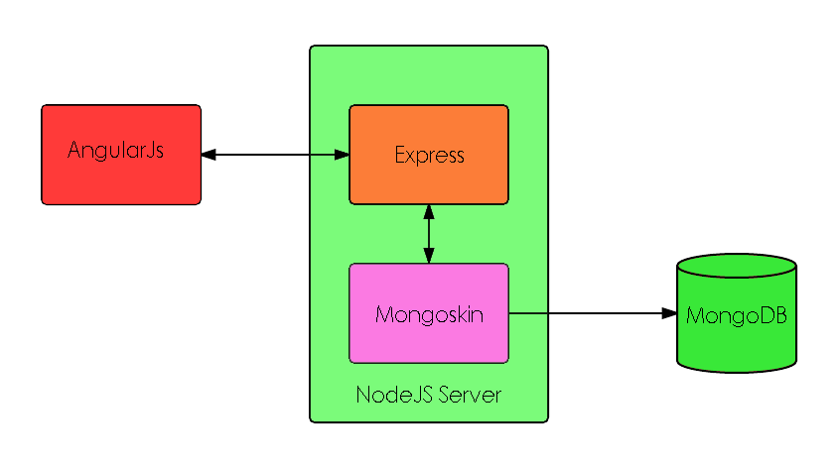

## System and Subsystem Decomposition

The system was built using an MVC-like architecture as represented below:

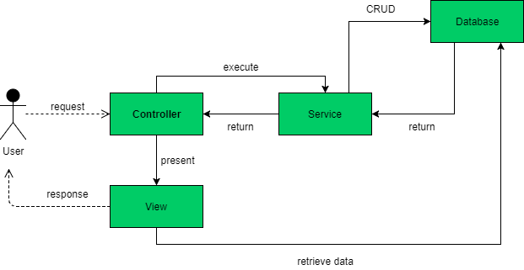

## 

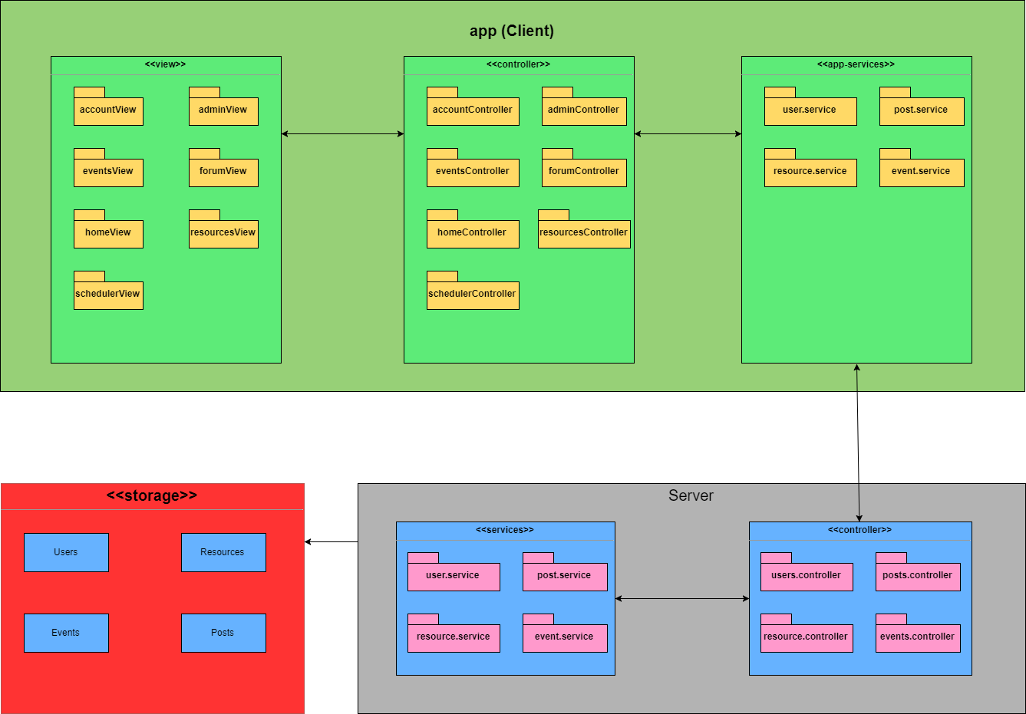

**Class Diagram**

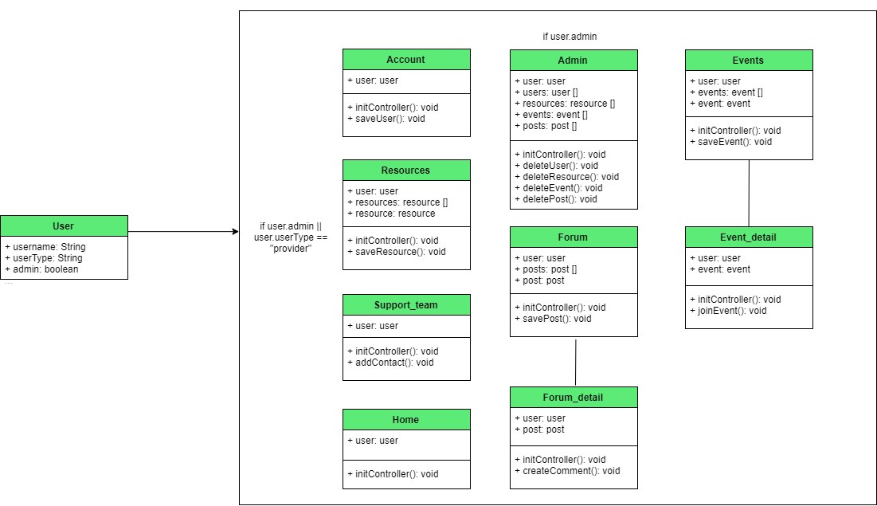

# 

# 

# 

# System Validation

Throughout the entire development cycle, manual testing was performed for each user story after completion. In the course of the development of each user story, testing was done in parts, and if that layer passed the testing process, another layer was developed and tested first individually, and then in addition to the previous layer. In order to gain an idea of how user-friendly and intuitive the app was, usability tests were also performed by having others use the application. Finally, during each bi-weekly meeting, the app was demoed so that the owner can validate the program herself.

# Glossary

|  |  |
| --- | --- |
| **Term** | **Definition** |
| Health Care Provider | A doctor of medicine or osteopathy who is authorized to practice medicine or surgery (as appropriate) by the State in which the doctor practices |
| Caregiver | A family member or paid helper who regularly looks after a child or a sick, elderly, or disabled person. |
| Web Application | A client–server computer program in which the client (including the user interface and client-side logic) runs in a **web** browser. |

# Appendix

## Appendix A - UML Diagrams

## Static UML Diagrams

Use case Diagram

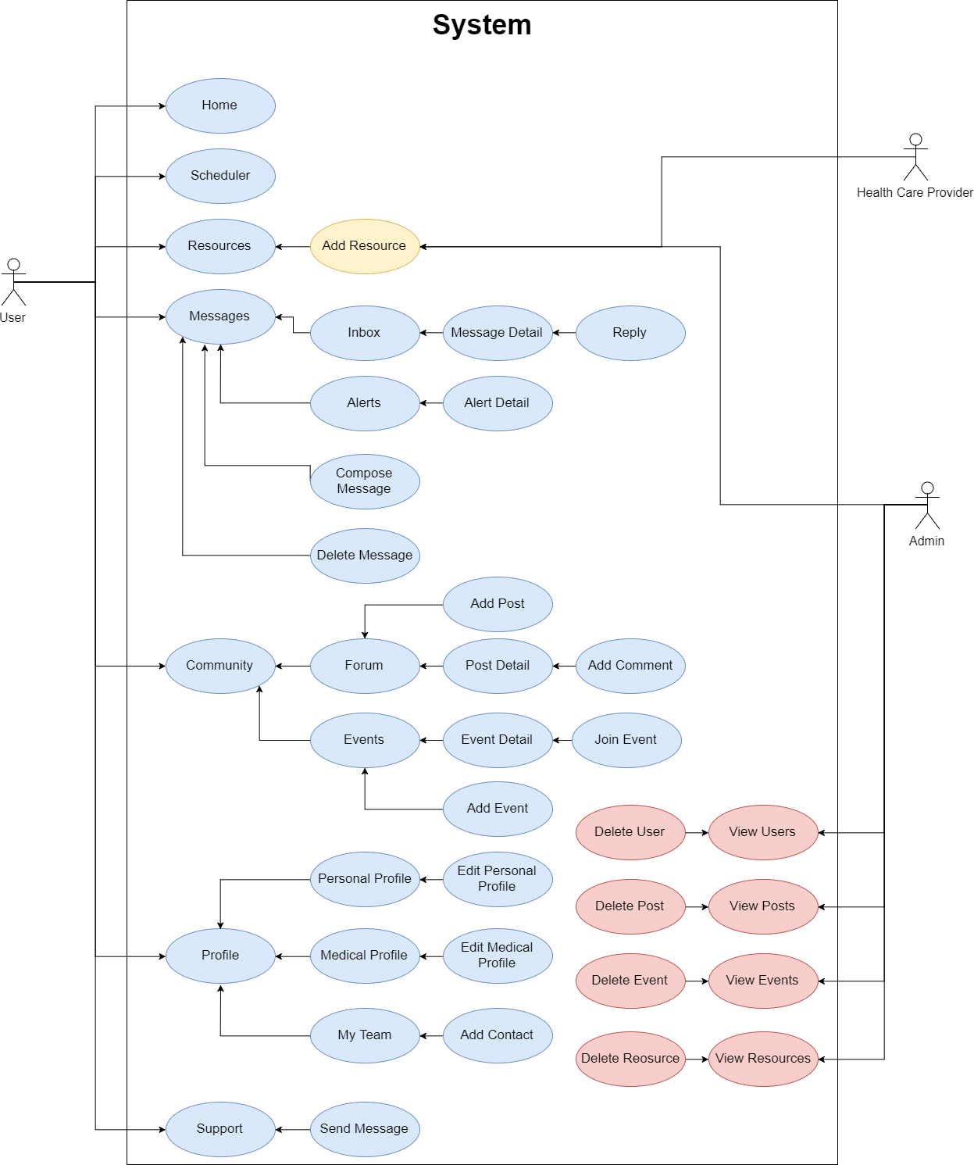

**Dynamic UML Diagrams (Not all diagrams are included)**

**User Story Name: Account Login**

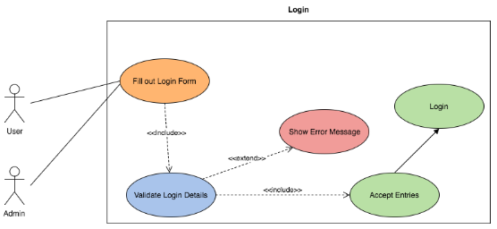

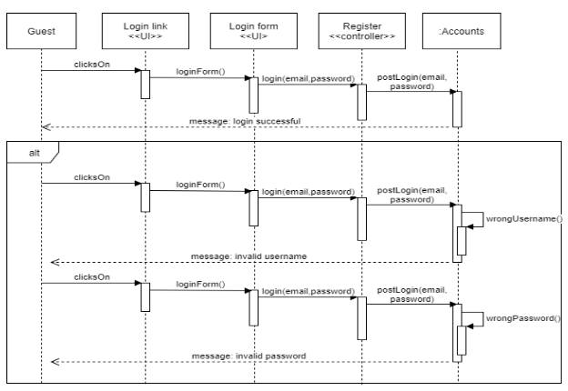

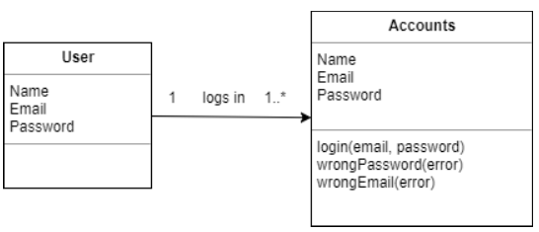

**User Story Name: Account Creation**

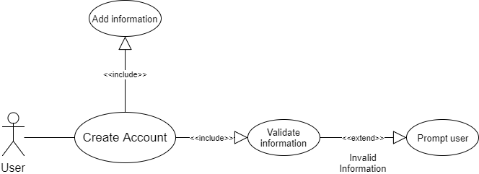

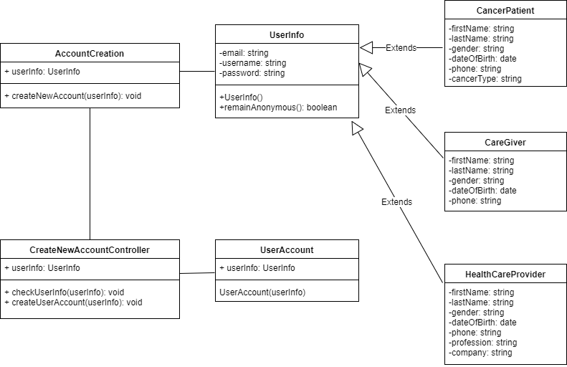

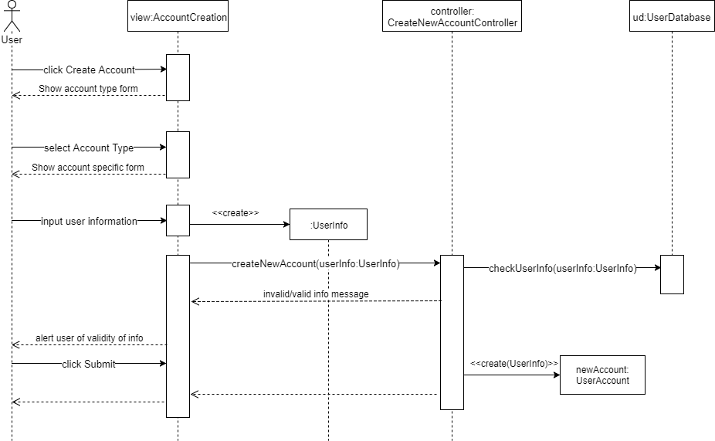

**User Story Name: Edit Profile**

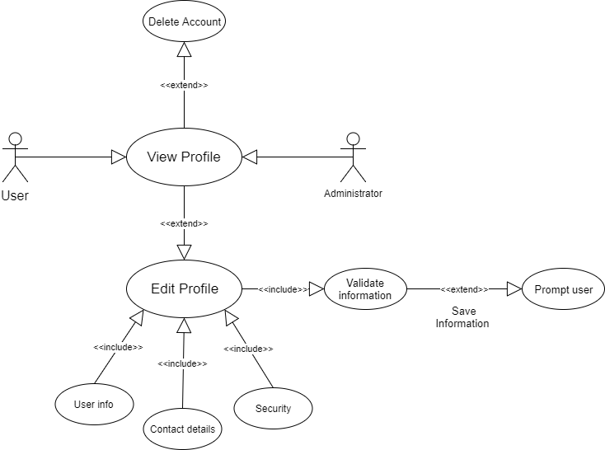

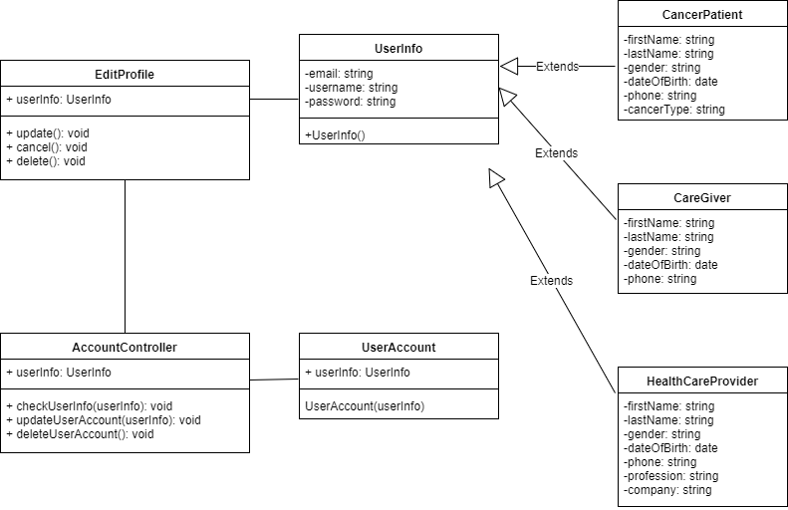

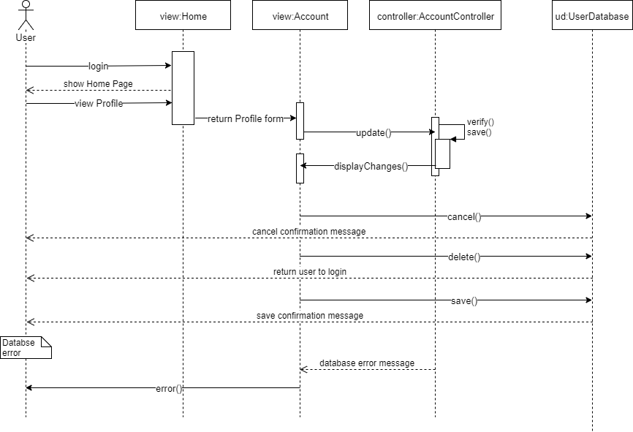

**User Story Name: Navigation Homepage**

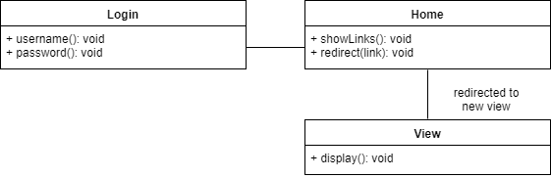

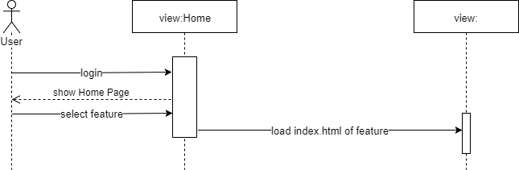

**User Story Name: Scheduler**

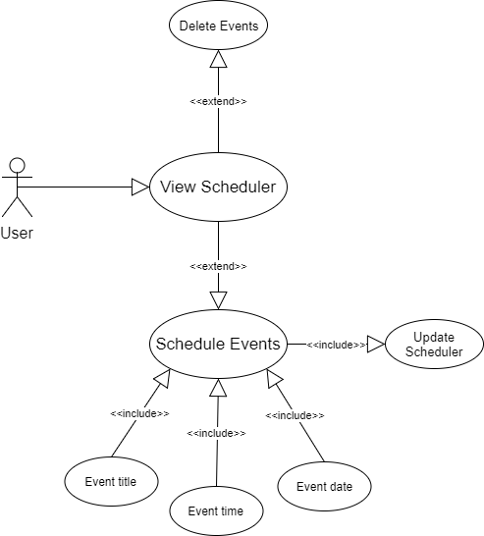

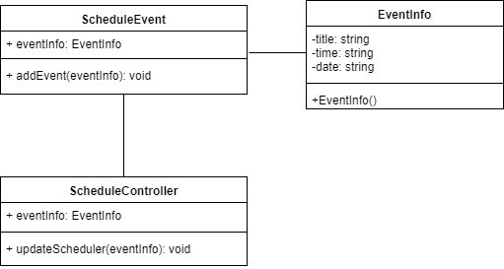

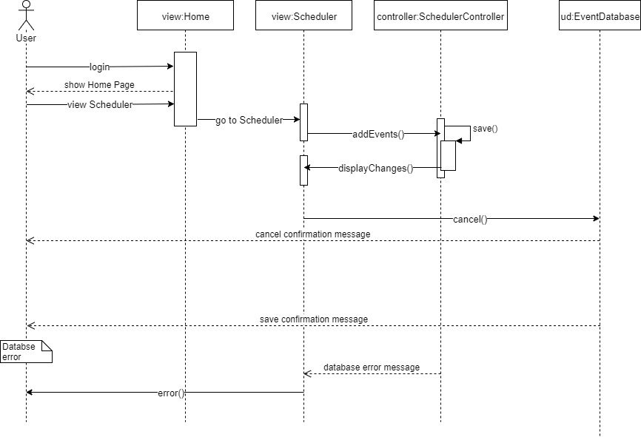

**User Story Name: Add Resource**

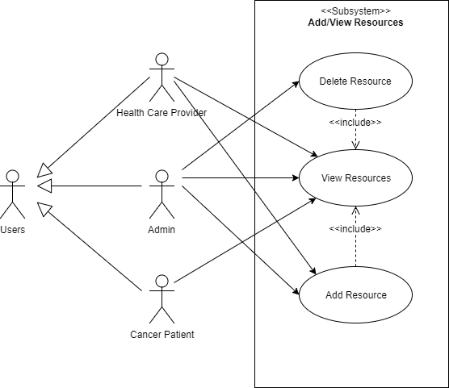

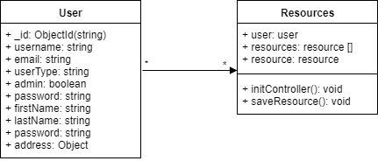

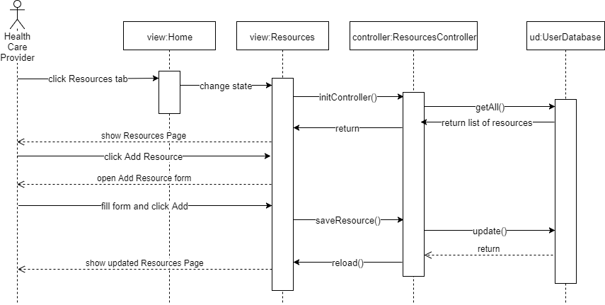

## 

## Appendix B - User Interface Design with User Manual

**Account Login**

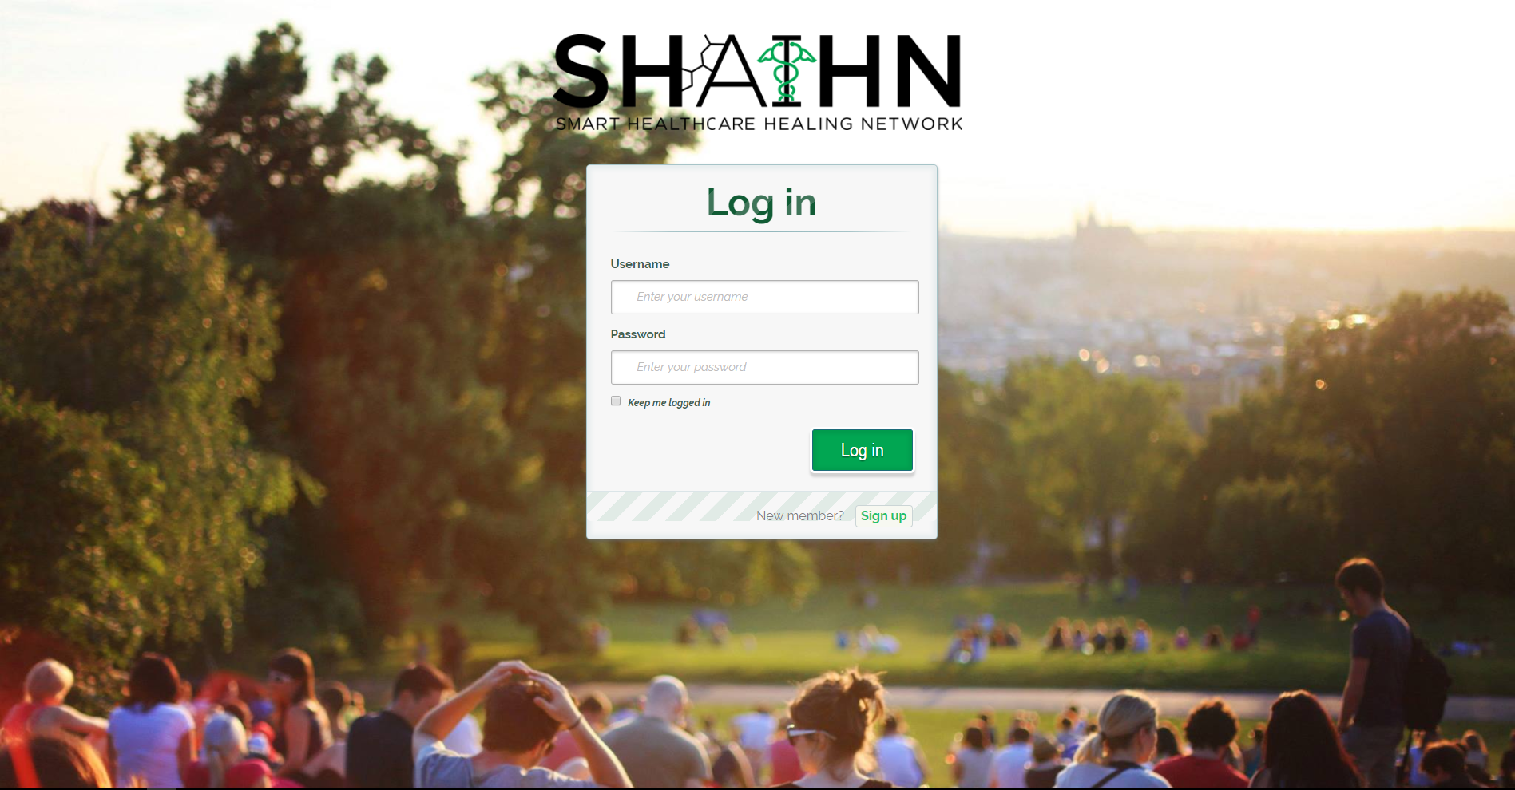

Use your credentials from when you created your account. If you haven’t yet created an account, click on the Sign up button.

**Account Creation**

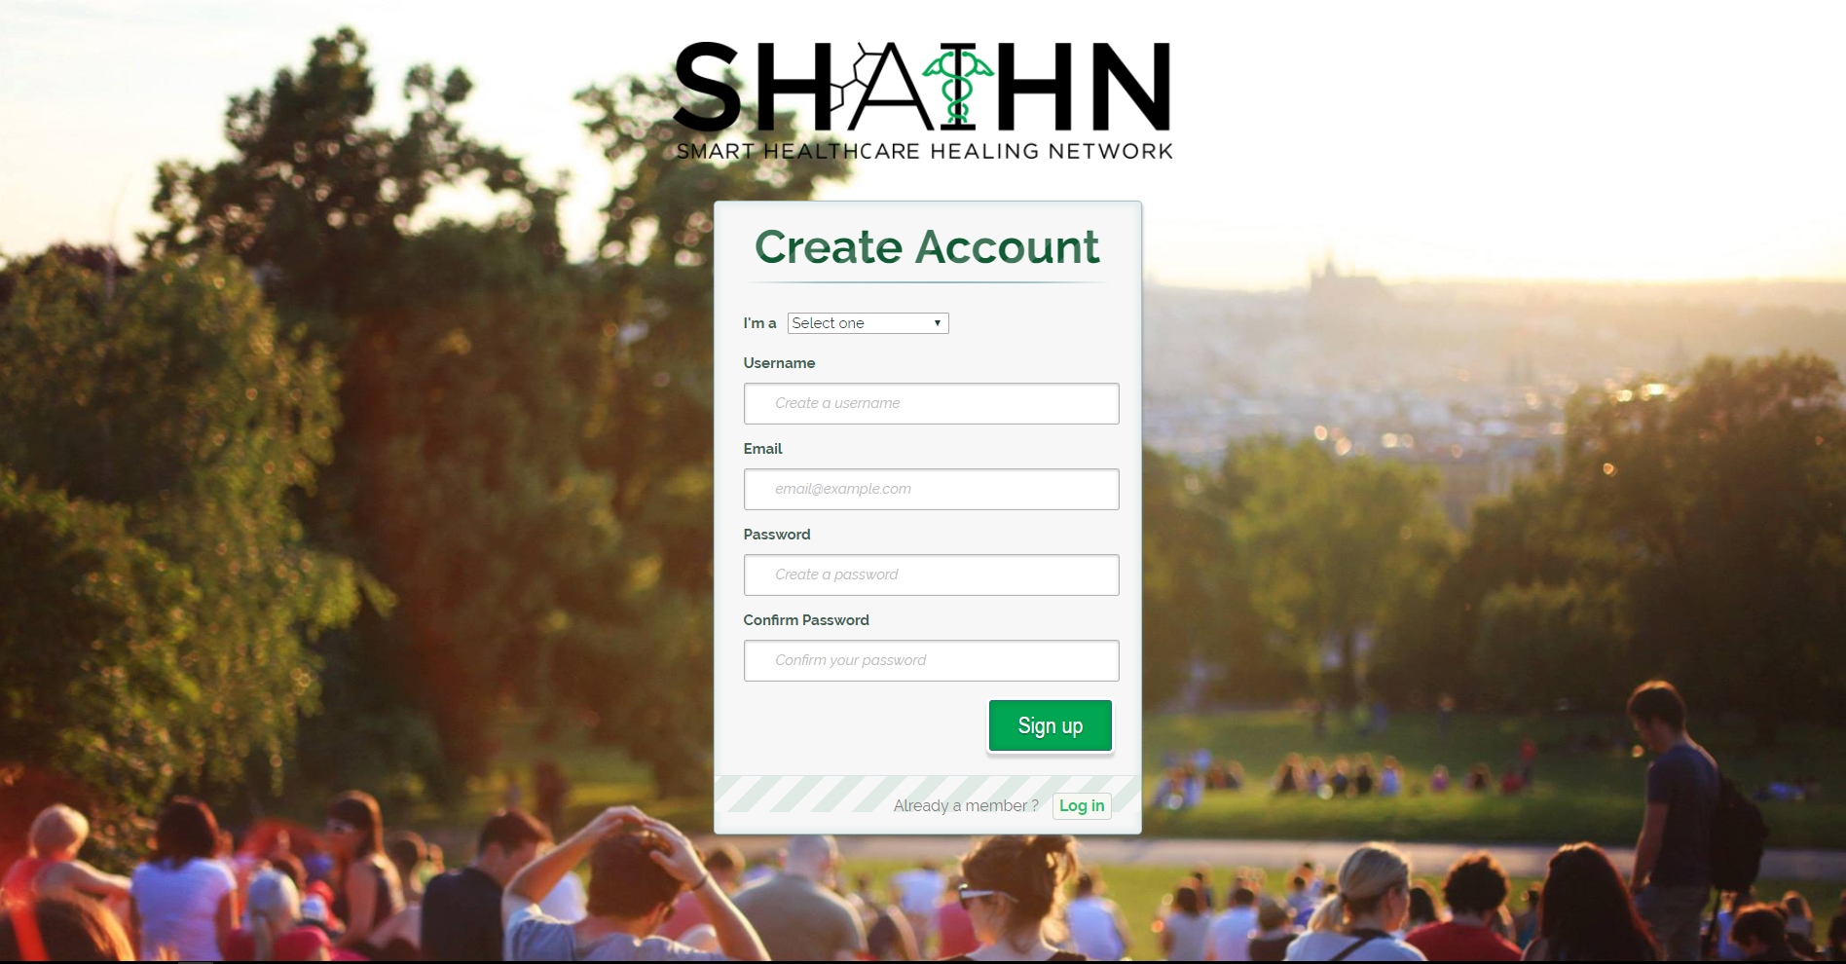

Fill in all the fields and select the type of user you are (health care provider or patient/caregiver). The first user becomes an admin.

**Home Page**

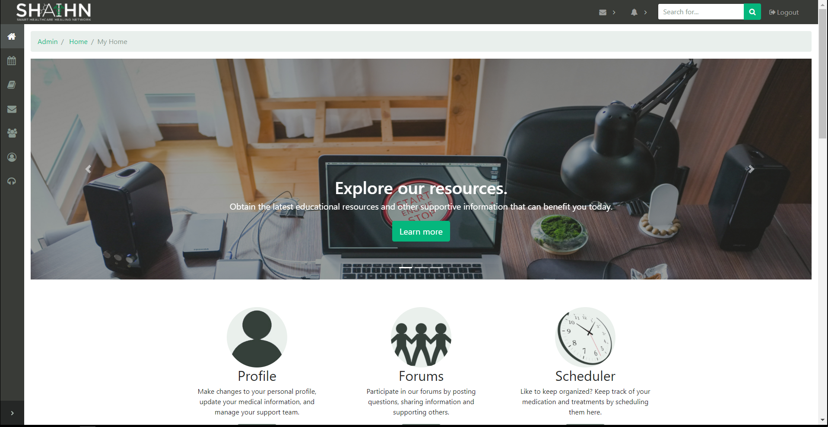

navigate anywhere in the site from this page.

**Scheduler**

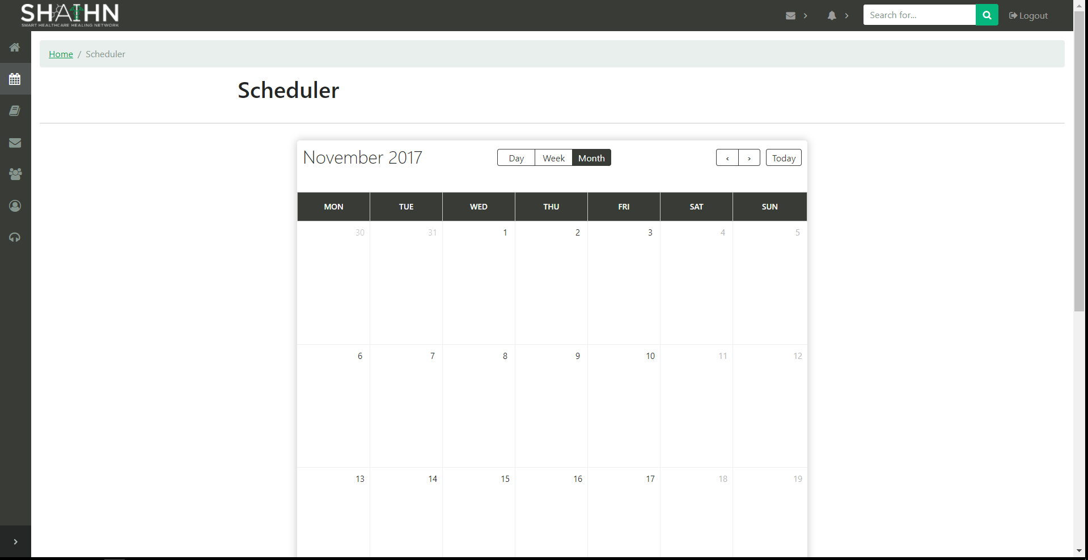

Add appointments or medication reminders by either dragging or selecting dates and writing in the dialog box that appears. (Front-end only)

**Resources**

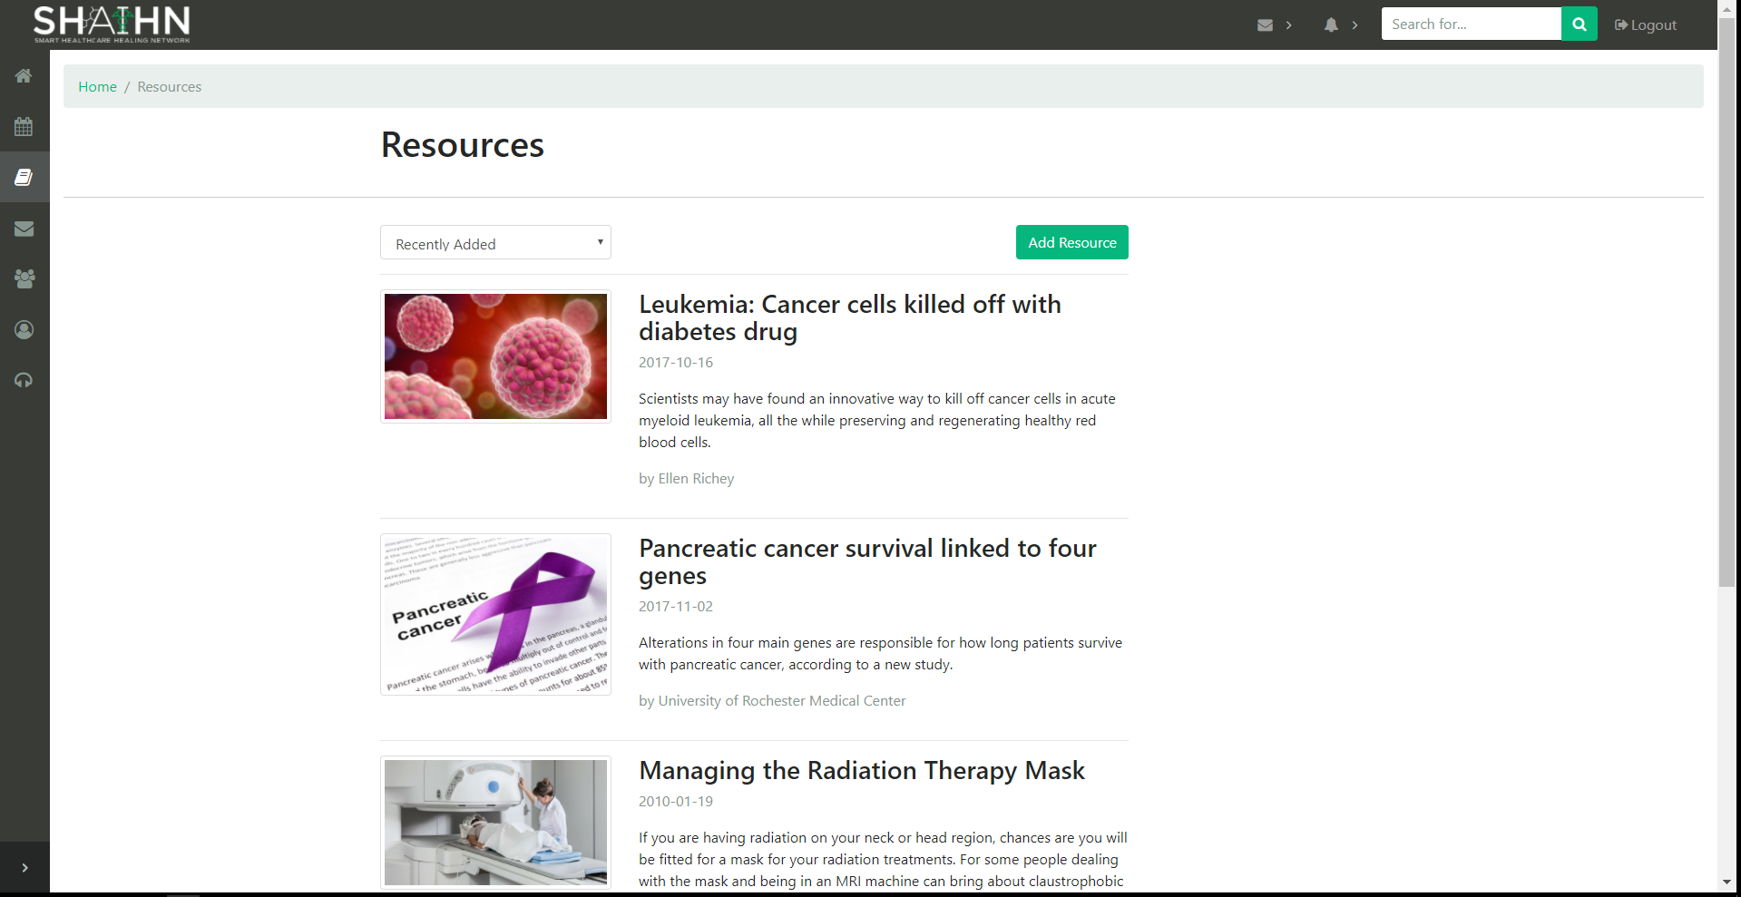

A list of resources. Clicking on a resource takes you to the article.

**Add Resource**

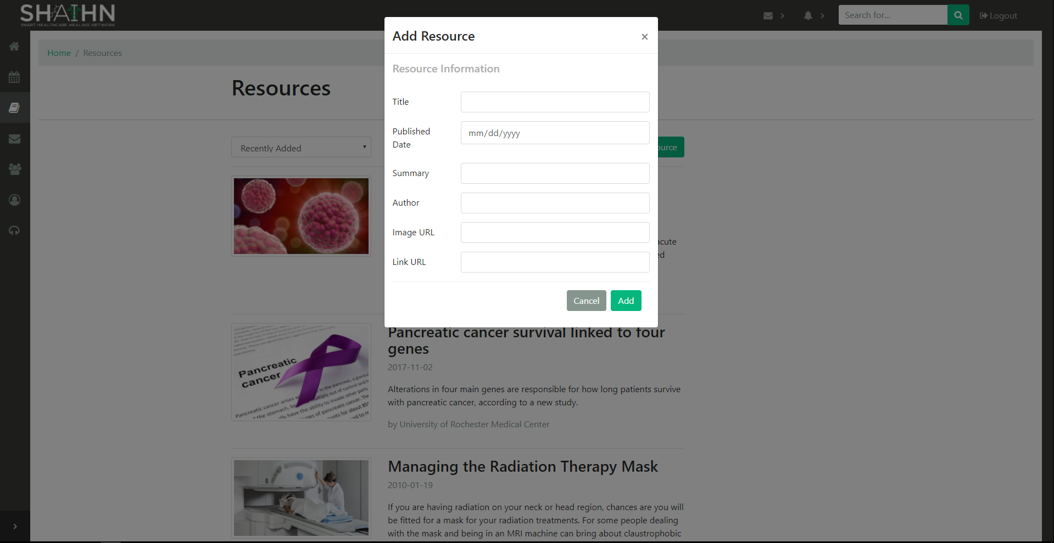

Feature only accessible by admins or health care providers. Fill in all the information to add the resource.

**Inbox**

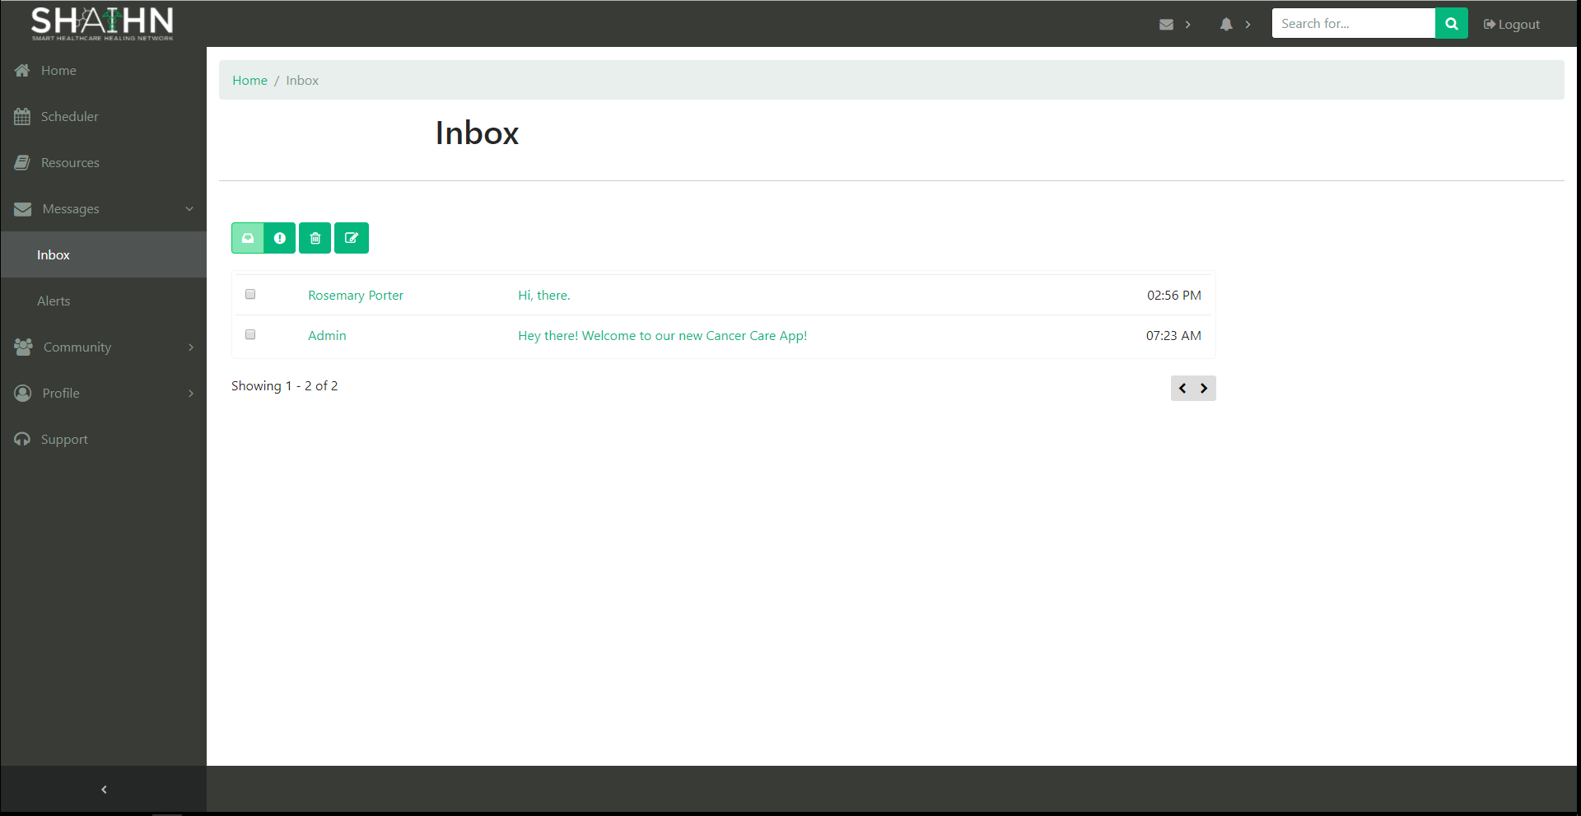

List of messages received. (Front-end only)

**Message Detail**

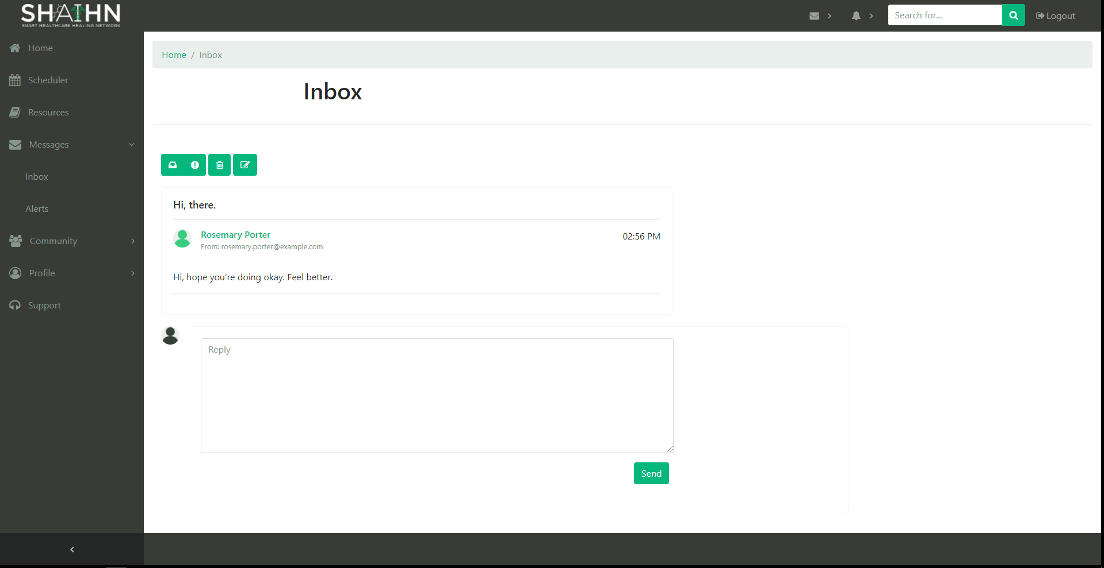

Shows the message body. Type in the textbox and click send to reply to the message. (Front-end only)

**Alerts**

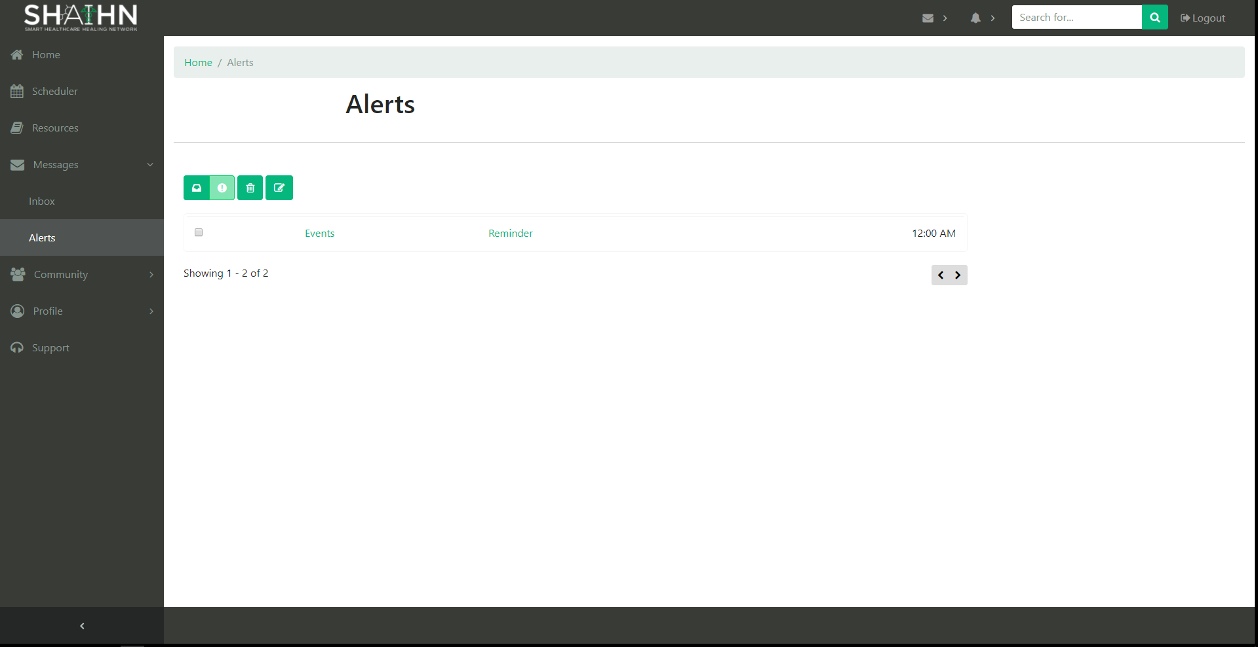

List of Alerts received. (Front-end only)

**Alert Detail**

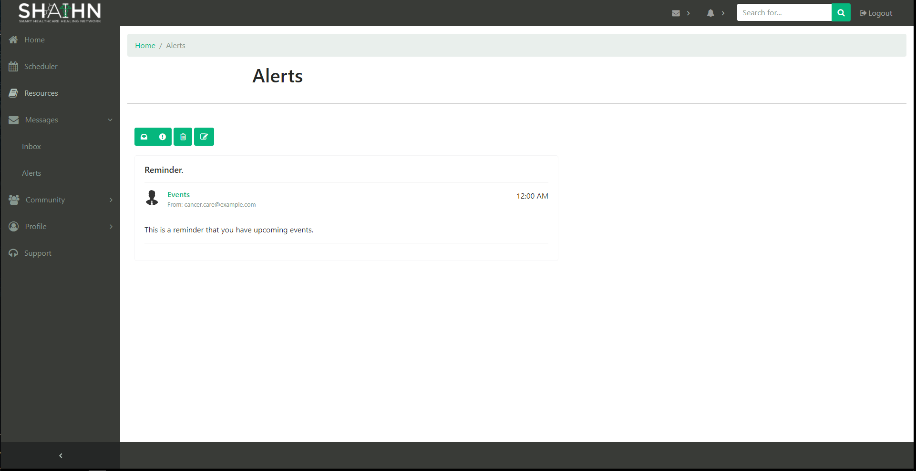

Shows the alert body. (Front-end only)

**Compose Message**

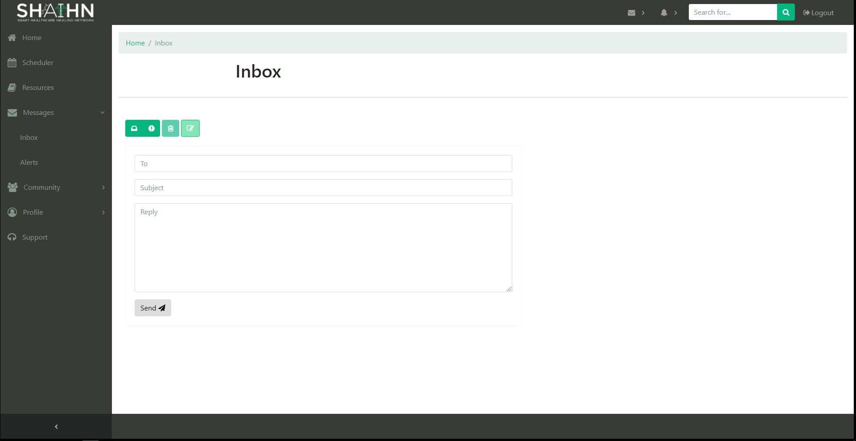

Fill in fields with email of user message is for, subject of message, and the message body. Then click send. (Front-end only)

**Forums**

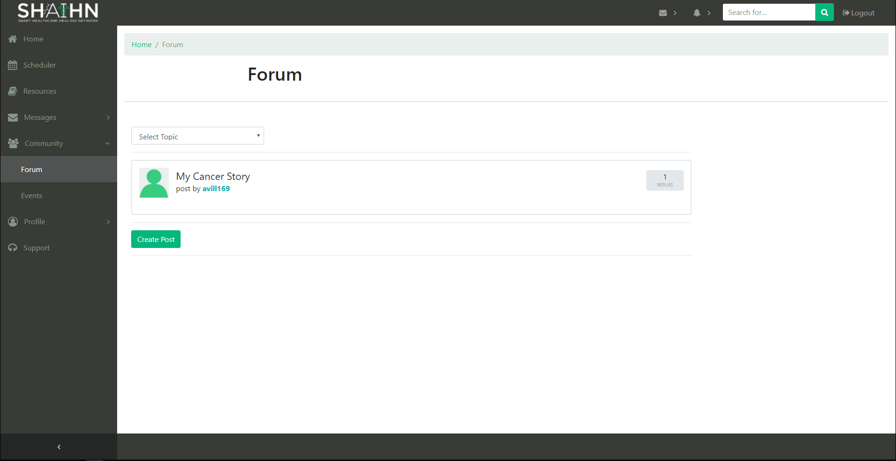

List of posts created by users.

**Forums Detail Page**

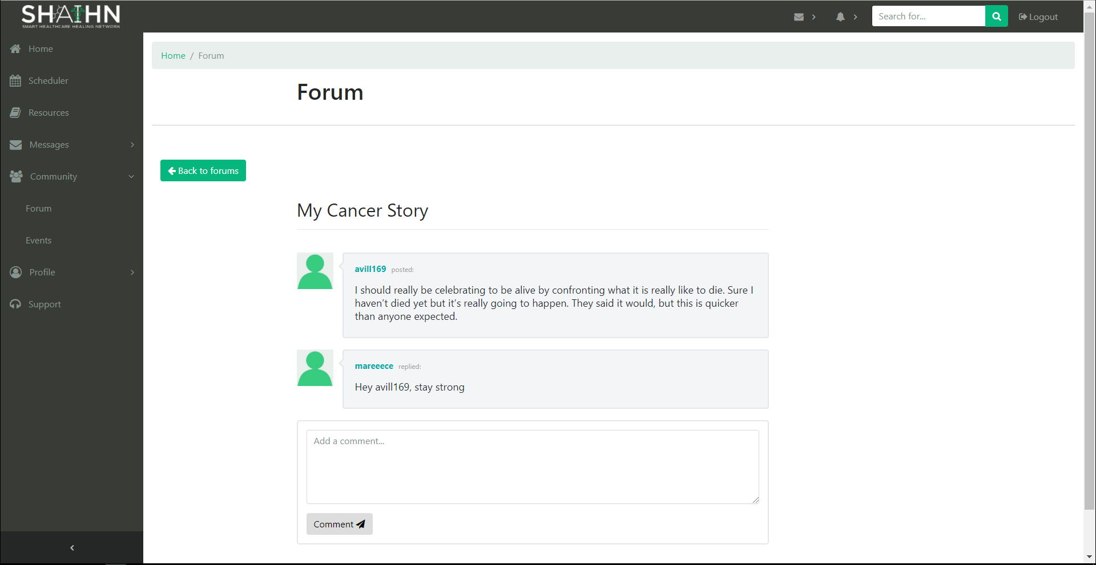

Shows post detail and allows a user to comment on the post. Type comment in textbox and click Comment.

**Add Post**

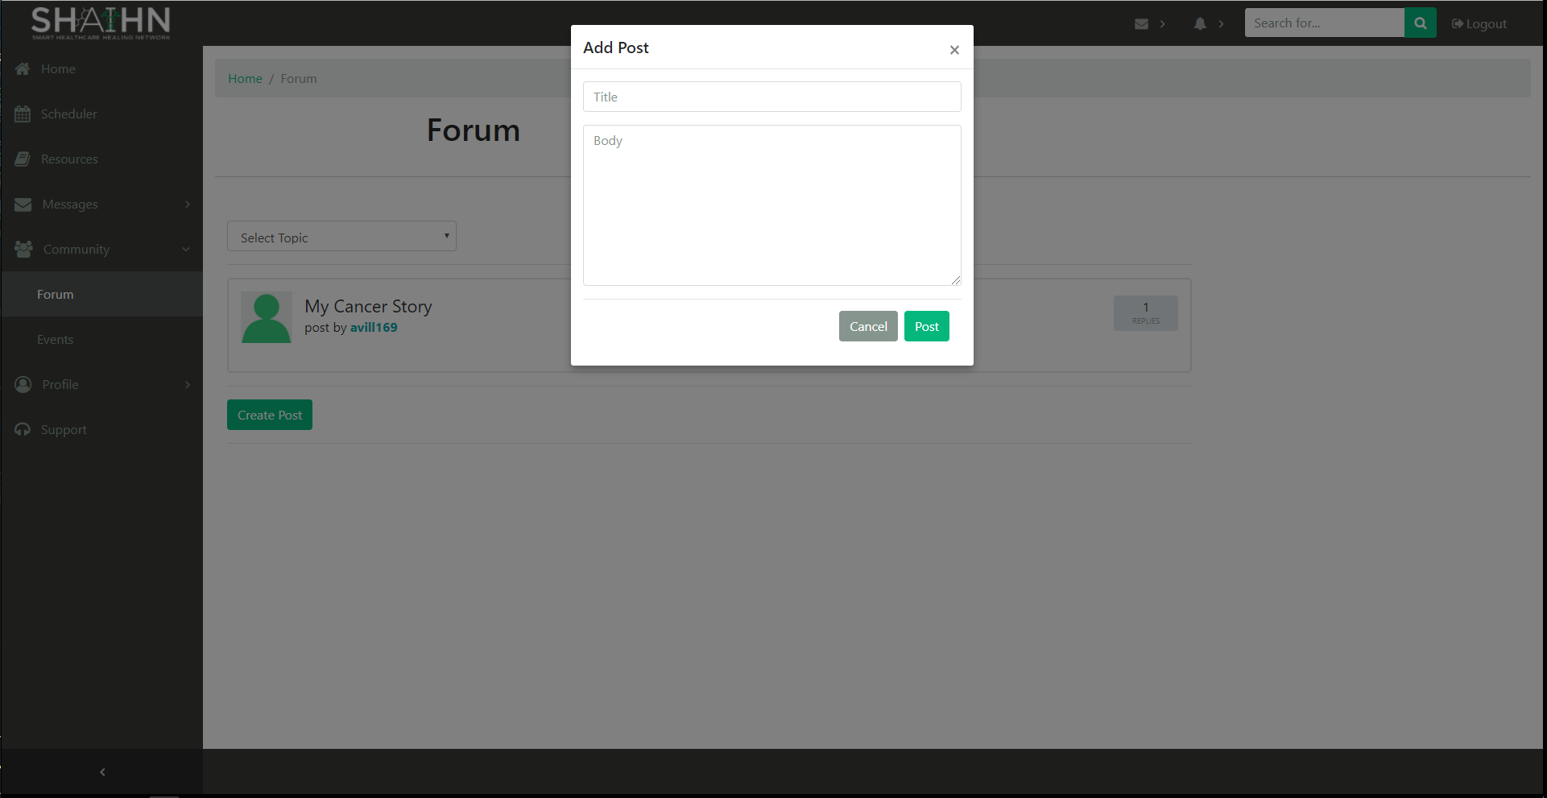

Each user can add a post by clicking Create Post. Fill in the field with a title and the post body, then click Post. To cancel, click cancel.

**Events**

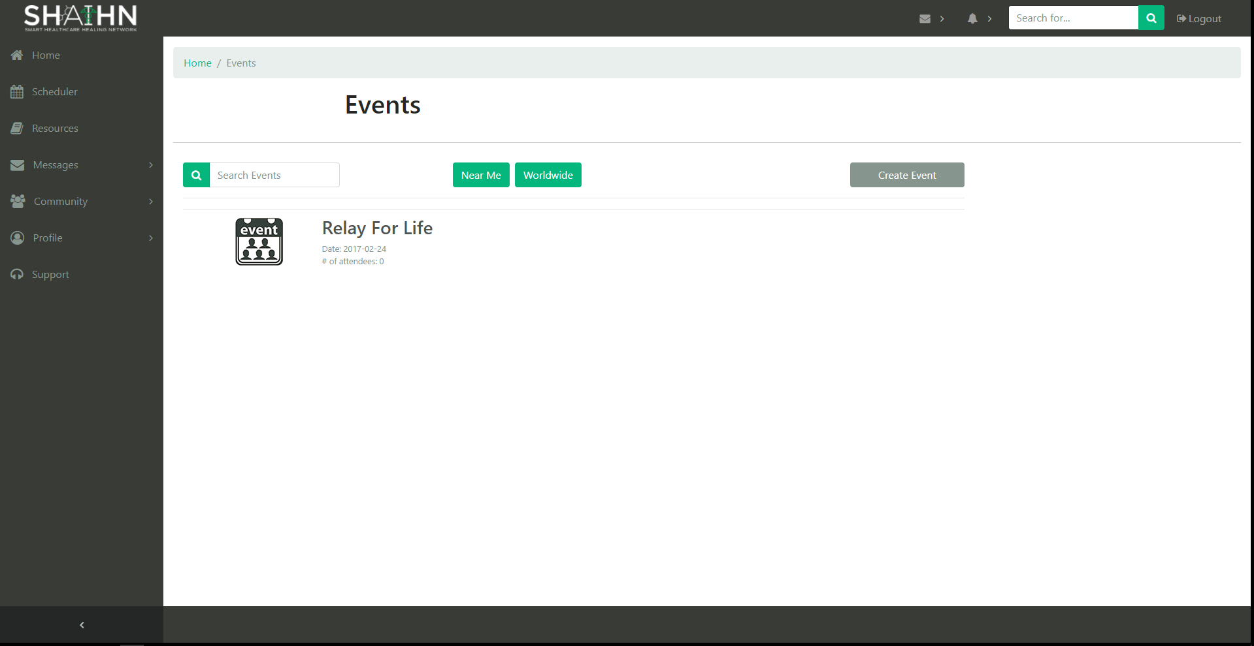

Shows list of events.

**Event Detail Page**

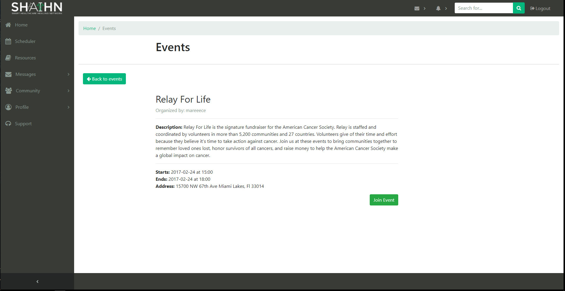

The detail page of an event. To join an event, click Join Event. User is redirected back to Events page if they clicked ‘Join Event’ or ‘Back to events’.

**Create Event**

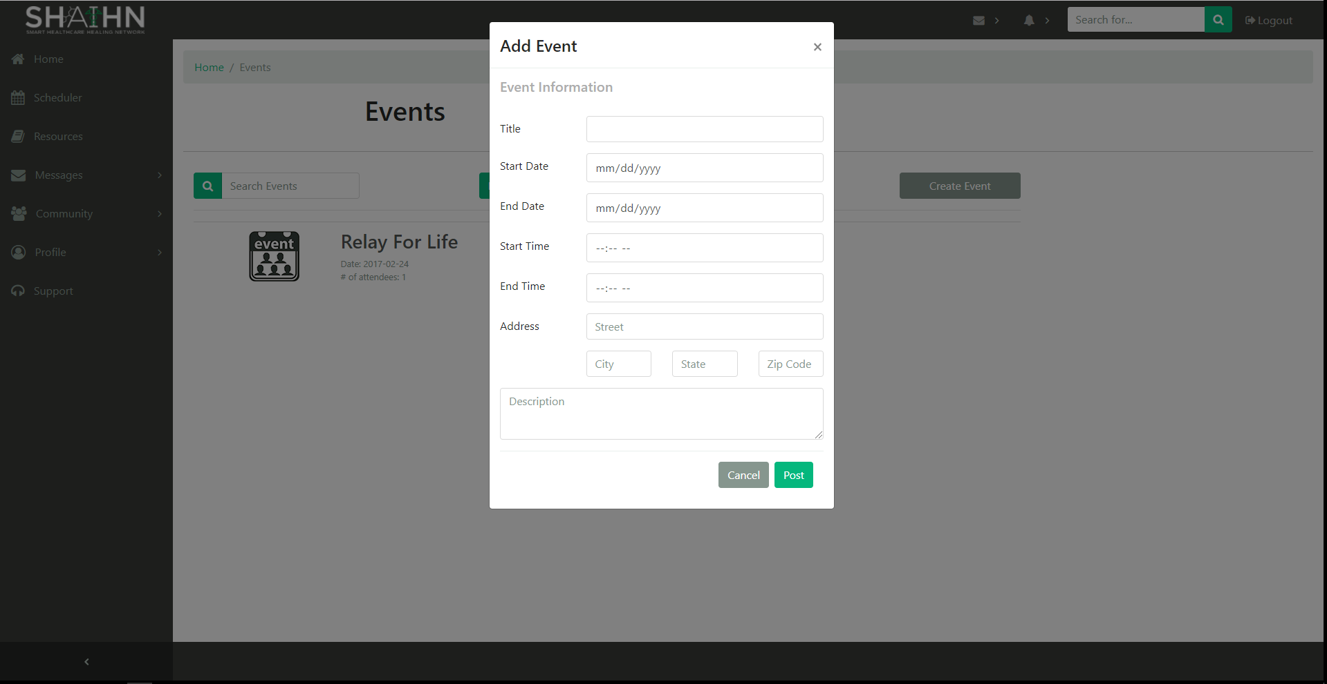

Each user can create an event. Fill in the fields, then click ‘Post’ to create the event. ‘Cancel’ closes the form.

**Personal Profile**

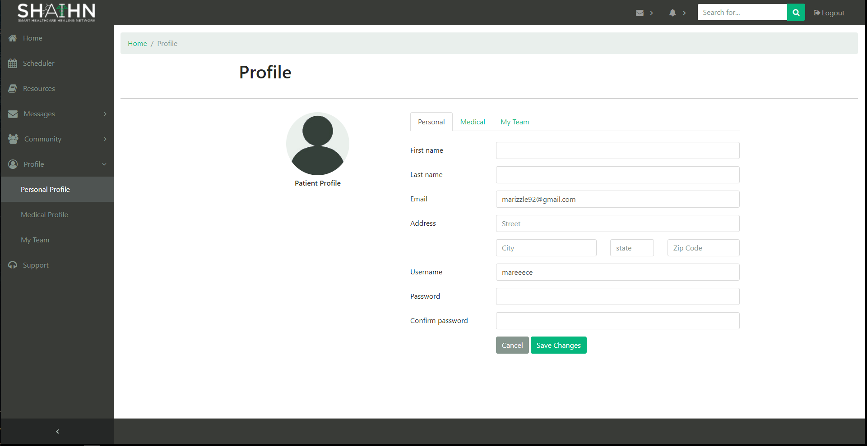

Users can update their personal information here. Fill in fields and click ‘Save Changes’.

**Medical Profile**

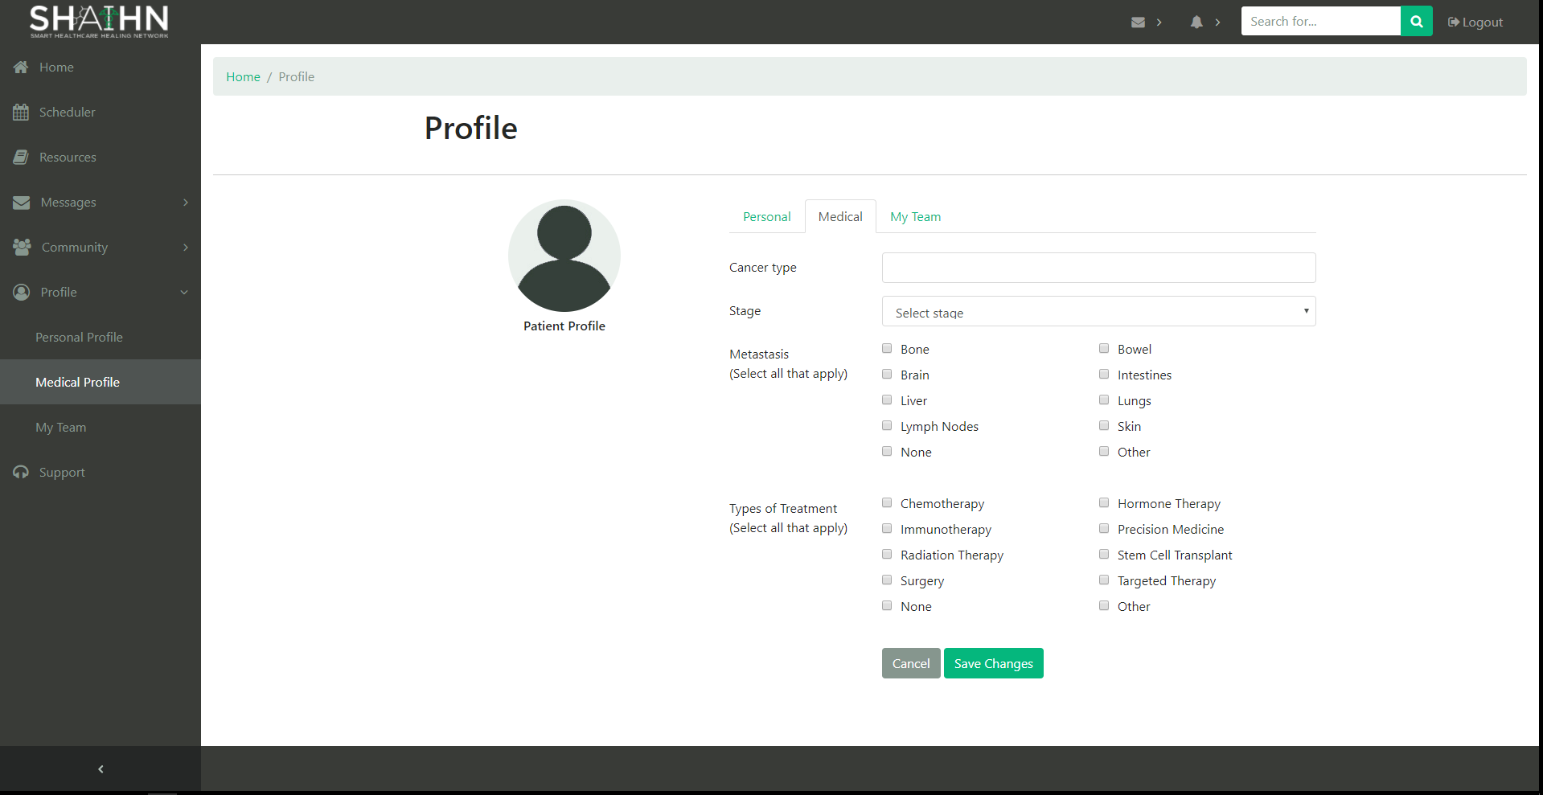

Users can update their medical information here. Fill in fields and click ‘Save Changes’. These are only fields related to a patient. We have not yet implemented a custom view for a healthcare provider's information.

**My Team**

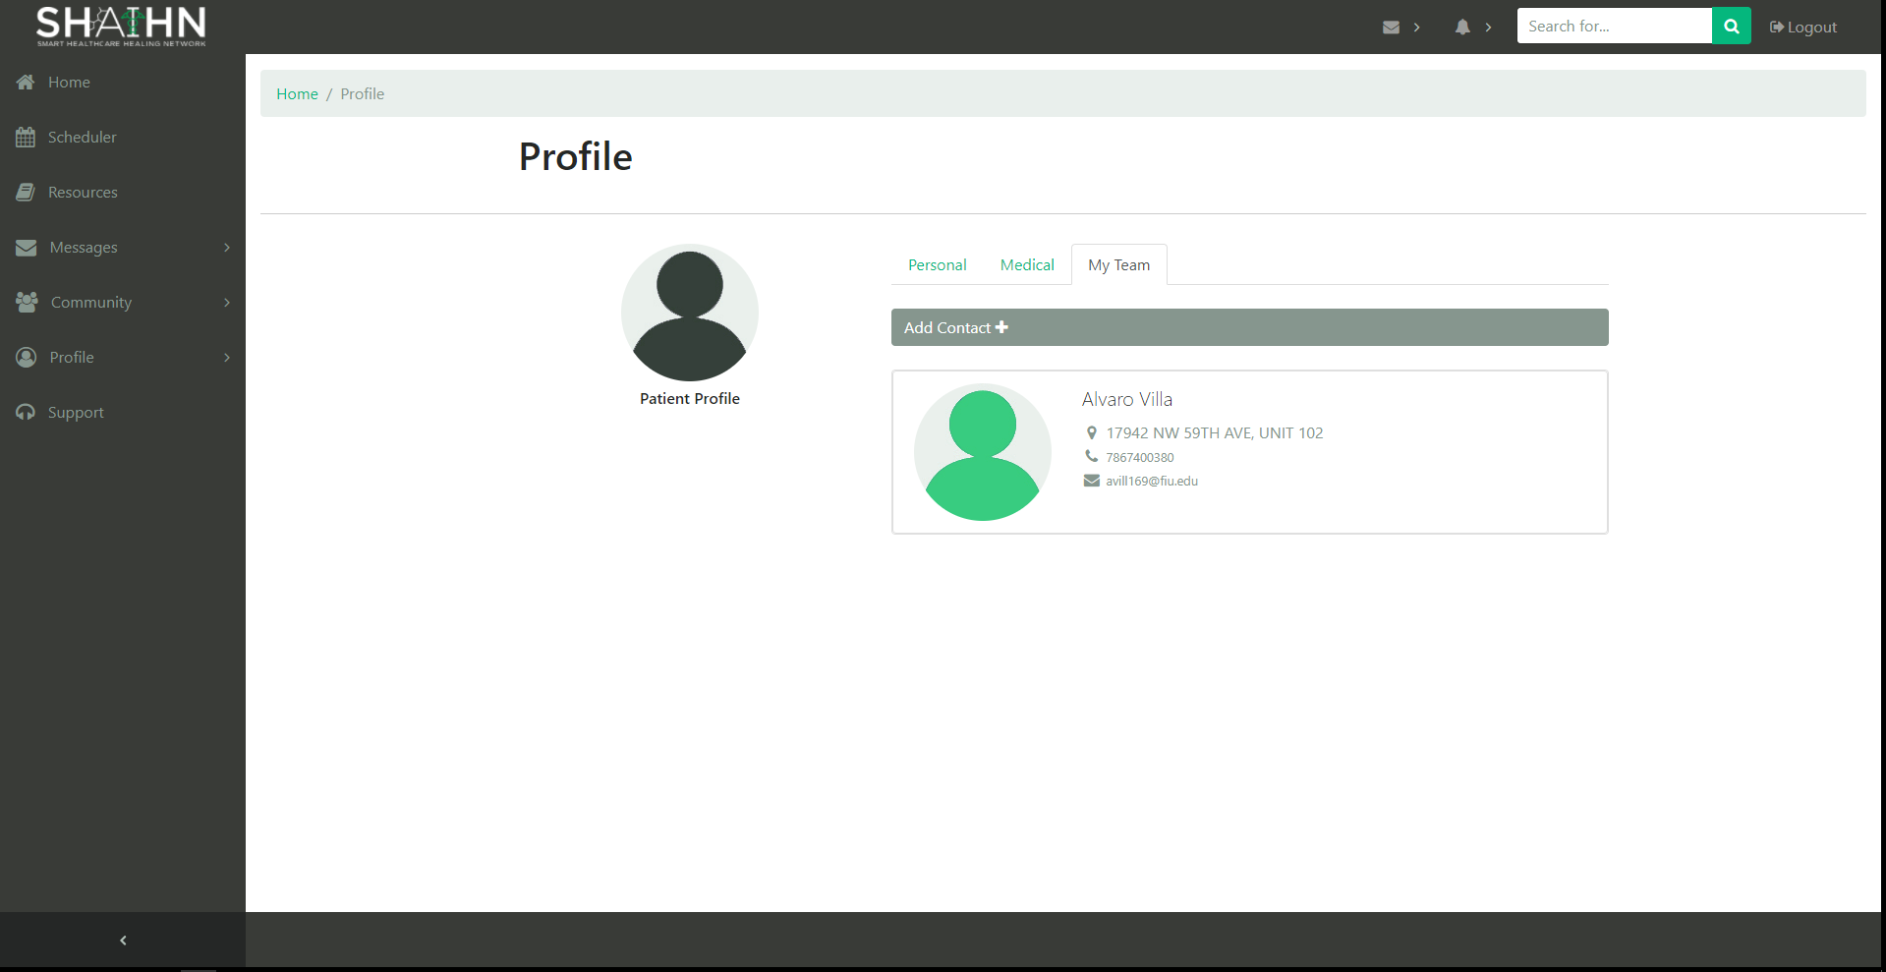

In the section My Team, users can view a list of the contacts they’ve added.

**Add Contact**

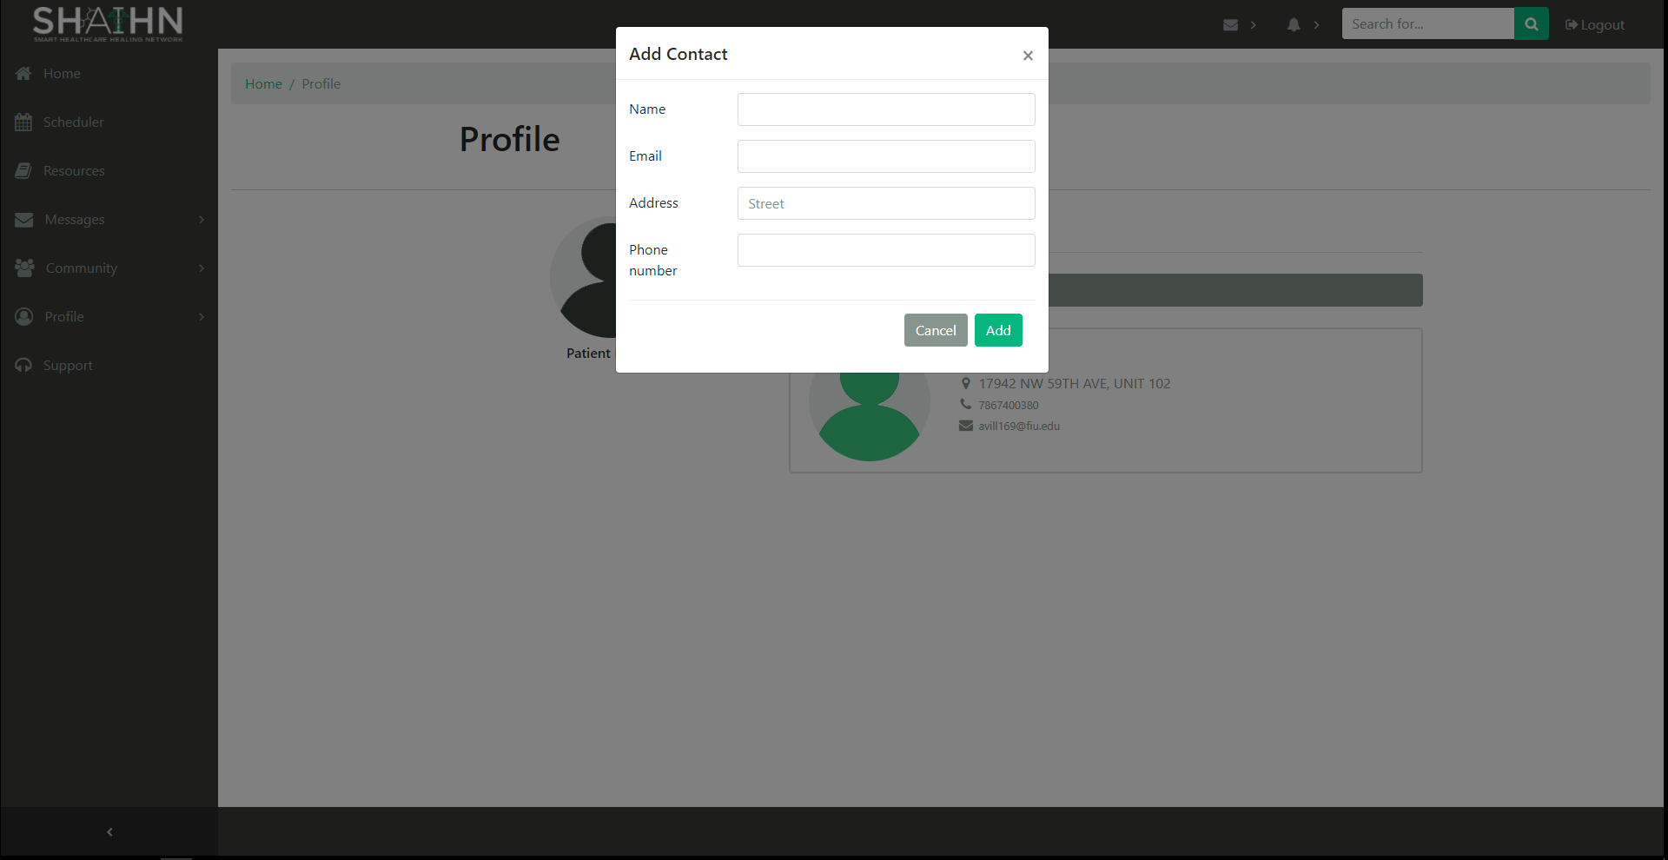

Users can add contacts by clicking the Add contact. Fill in the fields and click ‘Save Changes’.

**Support**

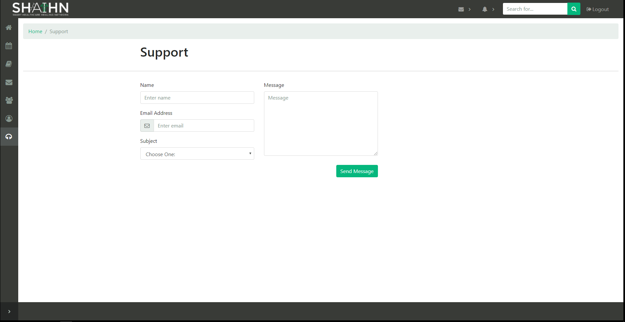

Users can send messages to the admin for any inquiries, suggestions, or any customer service related issues. (Front-end only)

**View Users (Admin)**

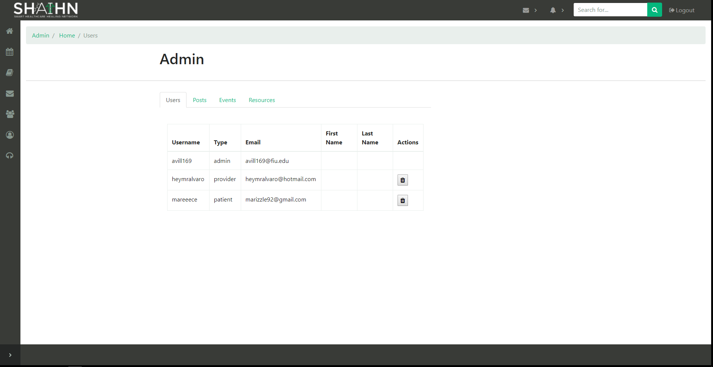

As an admin, you can view and delete users from the user collection of the database.

**View Posts (Admin)**

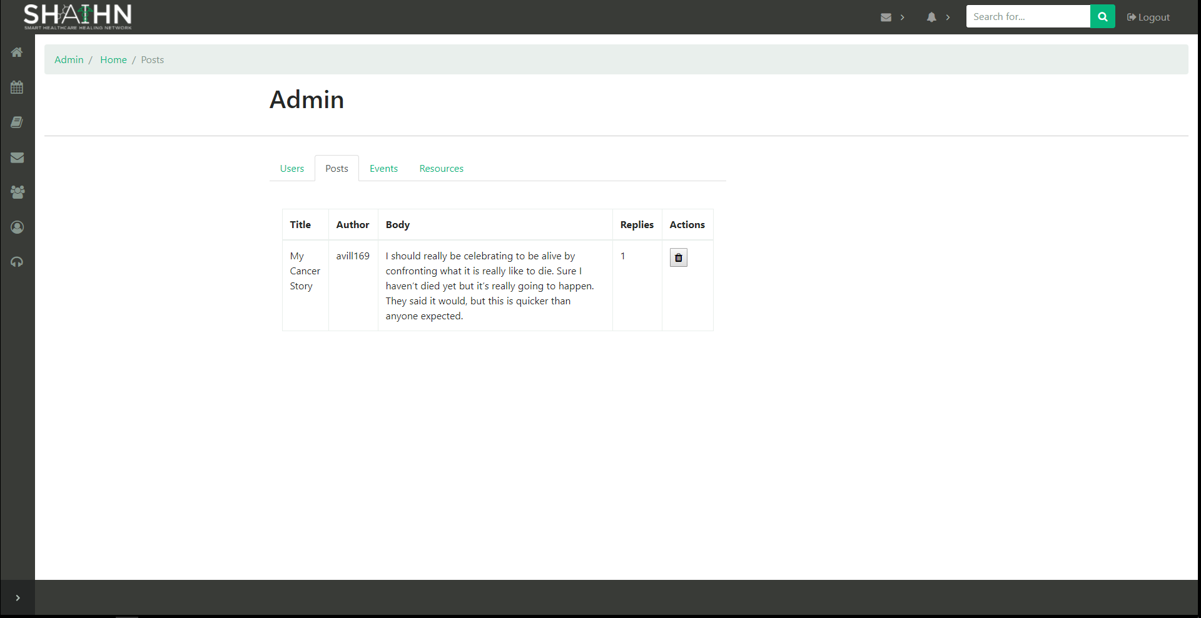

As an admin, you can view and delete posts from the post collection of the database.

**View Events (Admin)**

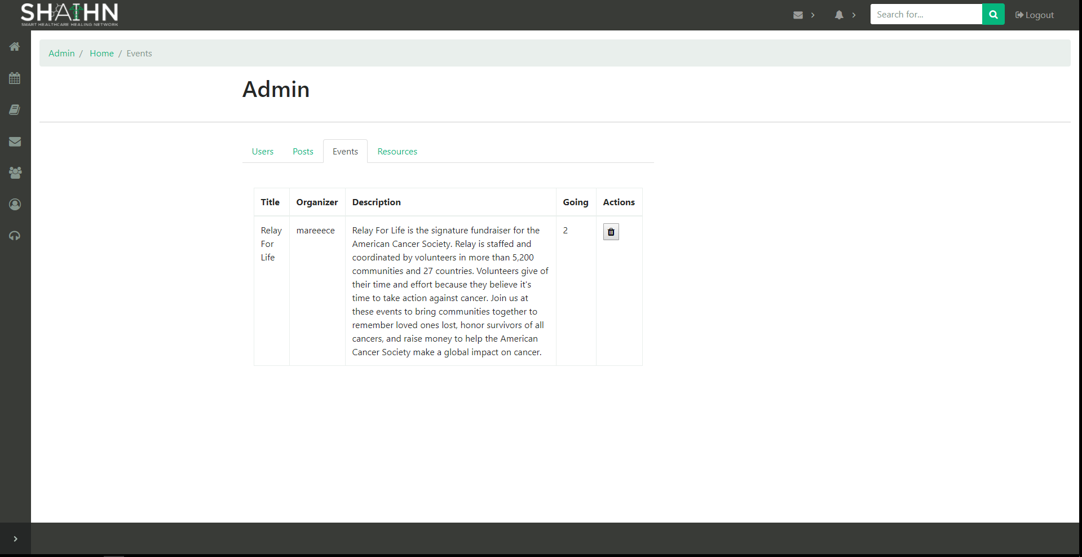

As an admin, you can view and delete events from the event collection of the database.

**View Resources (Admin)**

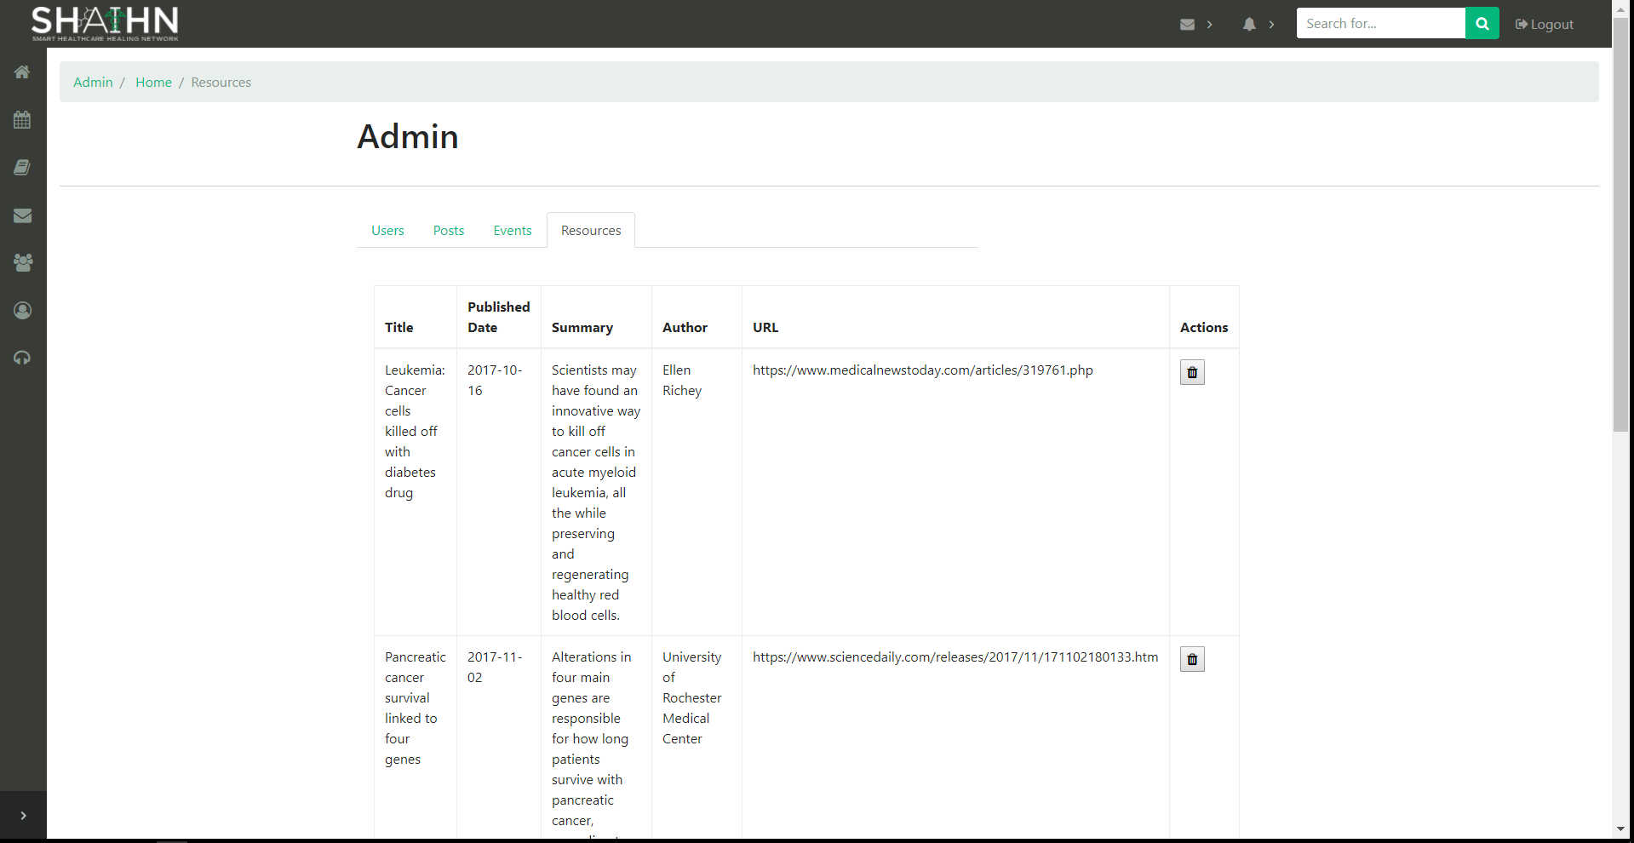

As an admin, you can view and delete resources from the resources collection of the database.

**Account Logout**

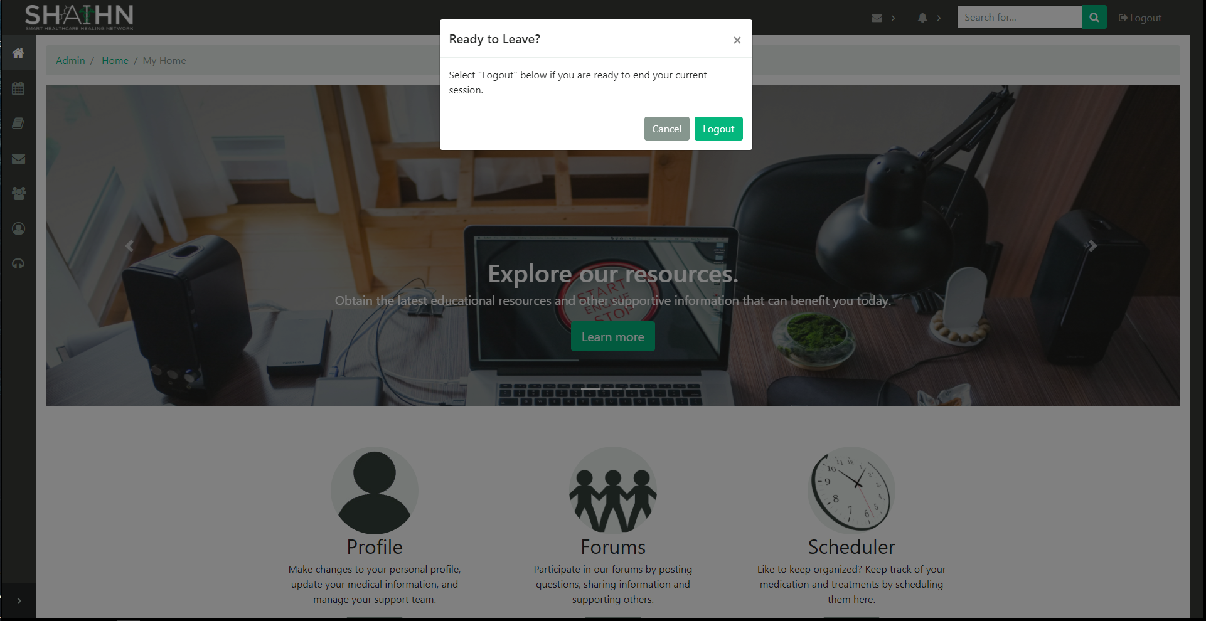

By clicking logout, you can logout of the system, and get redirected to the login page.

## Appendix C - Sprint Review Reports

### Sprint 1

**Review Meeting Minutes**

Attendees: Alvaro Villa, Kyle Roque, Annette King

Start time: 10/3/2017 12:30 PM

End time: 10/3/2017 12:45 PM

After a show and tell presentation, the implementation of the following user stories were accepted by the product owners:

* User Story 666: Account Creation
* User Story 667: Account Login
* User Story 668: Account Logout
* User Story 684: View Users
* User Story 685: Delete Users
* User Story 686: Edit Medical Profile (Patient)
* User Story 687: See Resources

The following ones were rejected and moved back to the product backlog to be assigned to a future sprint at a future Spring Planning meeting.

* None

### Sprint 2

**Review Meeting Minutes**

Attendees: Alvaro Villa, Kyle Roque, Annette King

Start time: 10/16/2017 12:30 PM

End time: 10/16/2017 12:45 PM

After a show and tell presentation, the implementation of the following user stories were accepted by the product owners:

* User Story 669: Edit Personal Profile (Patient)
* User Story 688: View Support Team
* User Story 689: Add Contact
* User Story 690: See Forum Posts
* User Story 691: View Forum Post Detail

The following ones were rejected and moved back to the product backlog to be assigned to a future sprint at a future Spring Planning meeting.

* None

### Sprint 3

**Review Meeting Minutes**

Attendees: Alvaro Villa, Kyle Roque, Annette King

Start time: 10/30/2017 2:30 PM

End time: 10/30/2017 2:45 PM

After a show and tell presentation, the implementation of the following user stories were accepted by the product owners:

* User Story 682: Navigation and homepage
* User Story 692: Add Forum Post
* User Story 693: Add Comment
* User Story 694: View Posts (Admin)
* User Story 695: Delete Posts

The following ones were rejected and moved back to the product backlog to be assigned to a future sprint at a future Spring Planning meeting.

* None

### Sprint 4

**Review Meeting Minutes**

Attendees: Alvaro Villa, Annette King

Start time: 10/30/2017 1:30 PM

End time: 10/30/2017 2:30 PM

After a show and tell presentation, the implementation of the following user stories were accepted by the product owners:

* User Story 670: Scheduler
* User Story 696: See Events
* User Story 697: View Event Detail
* User Story 698: Add Event
* User Story 699: Join Event

The following ones were rejected and moved back to the product backlog to be assigned to a future sprint at a future Spring Planning meeting.

* None

### Sprint 5

**Review Meeting Minutes**

Attendees: Alvaro Villa, Annette King

Start time: 11/27/2017 1:30 PM

End time: 11/27/2017 2:30 PM

After a show and tell presentation, the implementation of the following user stories were accepted by the product owners:

* User Story 683: Add Resource
* User Story 700: View Events (Admin)
* User Story 701: Delete Events
* User Story 702: View Resources (Admin)
* User Story 703: Delete Resources

The following ones were rejected and moved back to the product backlog to be assigned to a future sprint at a future Spring Planning meeting.

* None

## Appendix D - Installation Document, Shortcomings/Wishlist Document and other documents

## Installation Document

To run the app locally, you must have NodeJS installed and MongoDB running. Install NodeJS from <https://nodejs.org/> using the default options. Install MongoDB from <https://www.mongodb.org/downloads> using the complete setup type with the default options.

**To run MongoDB:**

Create an empty folder at “C:\data\db”

This is where MongoDB stores all its data.

Open Command Prompt, and run “mongod.exe” located in:

“C:\Program Files\MongoDB\Server\[MONGODB VERSION]\bin\mongod”. So if the MongoDB version installed is 3.2 then the command:

“C:\Program Files\MongoDB\Server\3.2\bin\mongod” will start MongoDB

**Project Setup:**

Run the command “npm install” from the project root folder (where the package.json is located) to download all node package dependencies.

From the same location, run “node server.js” to start the web server. Go to <http://localhost:3000> to access the application.

## Shortcomings and Wishlist

At its current state, the app doesn’t clearly present itself to first time users the motive and use of the system. For future iterations of the project, it recommended that developers address this issue by heightening the user interface with indicators and clarifications to some of the features of the site.

In addition, some features lack back-end support. However, completed features can easily be used as a template to support the development team. It is encouraged for the next iteration to include new features that can benefit all users of the site. The admin page, for instance, can make good use of the addition of other actions that can be performed. As it stands, the admin can only delete items from the database. Threaded comments is another feature that can be added. The idea for users to reply to other comments rather than just the original post is one that can improve the forum page, making conversations amongst users more interactive and less open-ended.

Finally, an important feature that should be added is the ability to verify users when creating accounts. For example, in this version, anyone can create an account as a health care provider since there is no way at the moment to verify them as such.

## References

1. Tips and guidelines from Moodle
2. Mongoskin Tutorial with Examples https://www.hacksparrow.com/mongoskin-tutorial-with-examples.html